Filmtopia - Project Section 1: Discussion

Introduction
For this first section of the project I put together a presentation on Filmtopia, the system I am proposing to build for a small independent cinema. The idea was to take everything the cinema currently does on paper and spreadsheets and bring it into one program, covering ticket bookings, seating and food and drink orders.
I created a PowerPoint so that I could present the proposal to my teacher, to other students on my course and to people standing in for the cinema's staff and manager. The aim of presenting it was to check that the project is worth doing and broad enough to work on before I get into the detail, and to gather feedback I could use to refine my understanding of the problem. The slides from that presentation are included below, followed by the feedback I received and my responses to it.

Presentation Click to expand/minimise
The following screenshots are taken from the PowerPoint I presented.

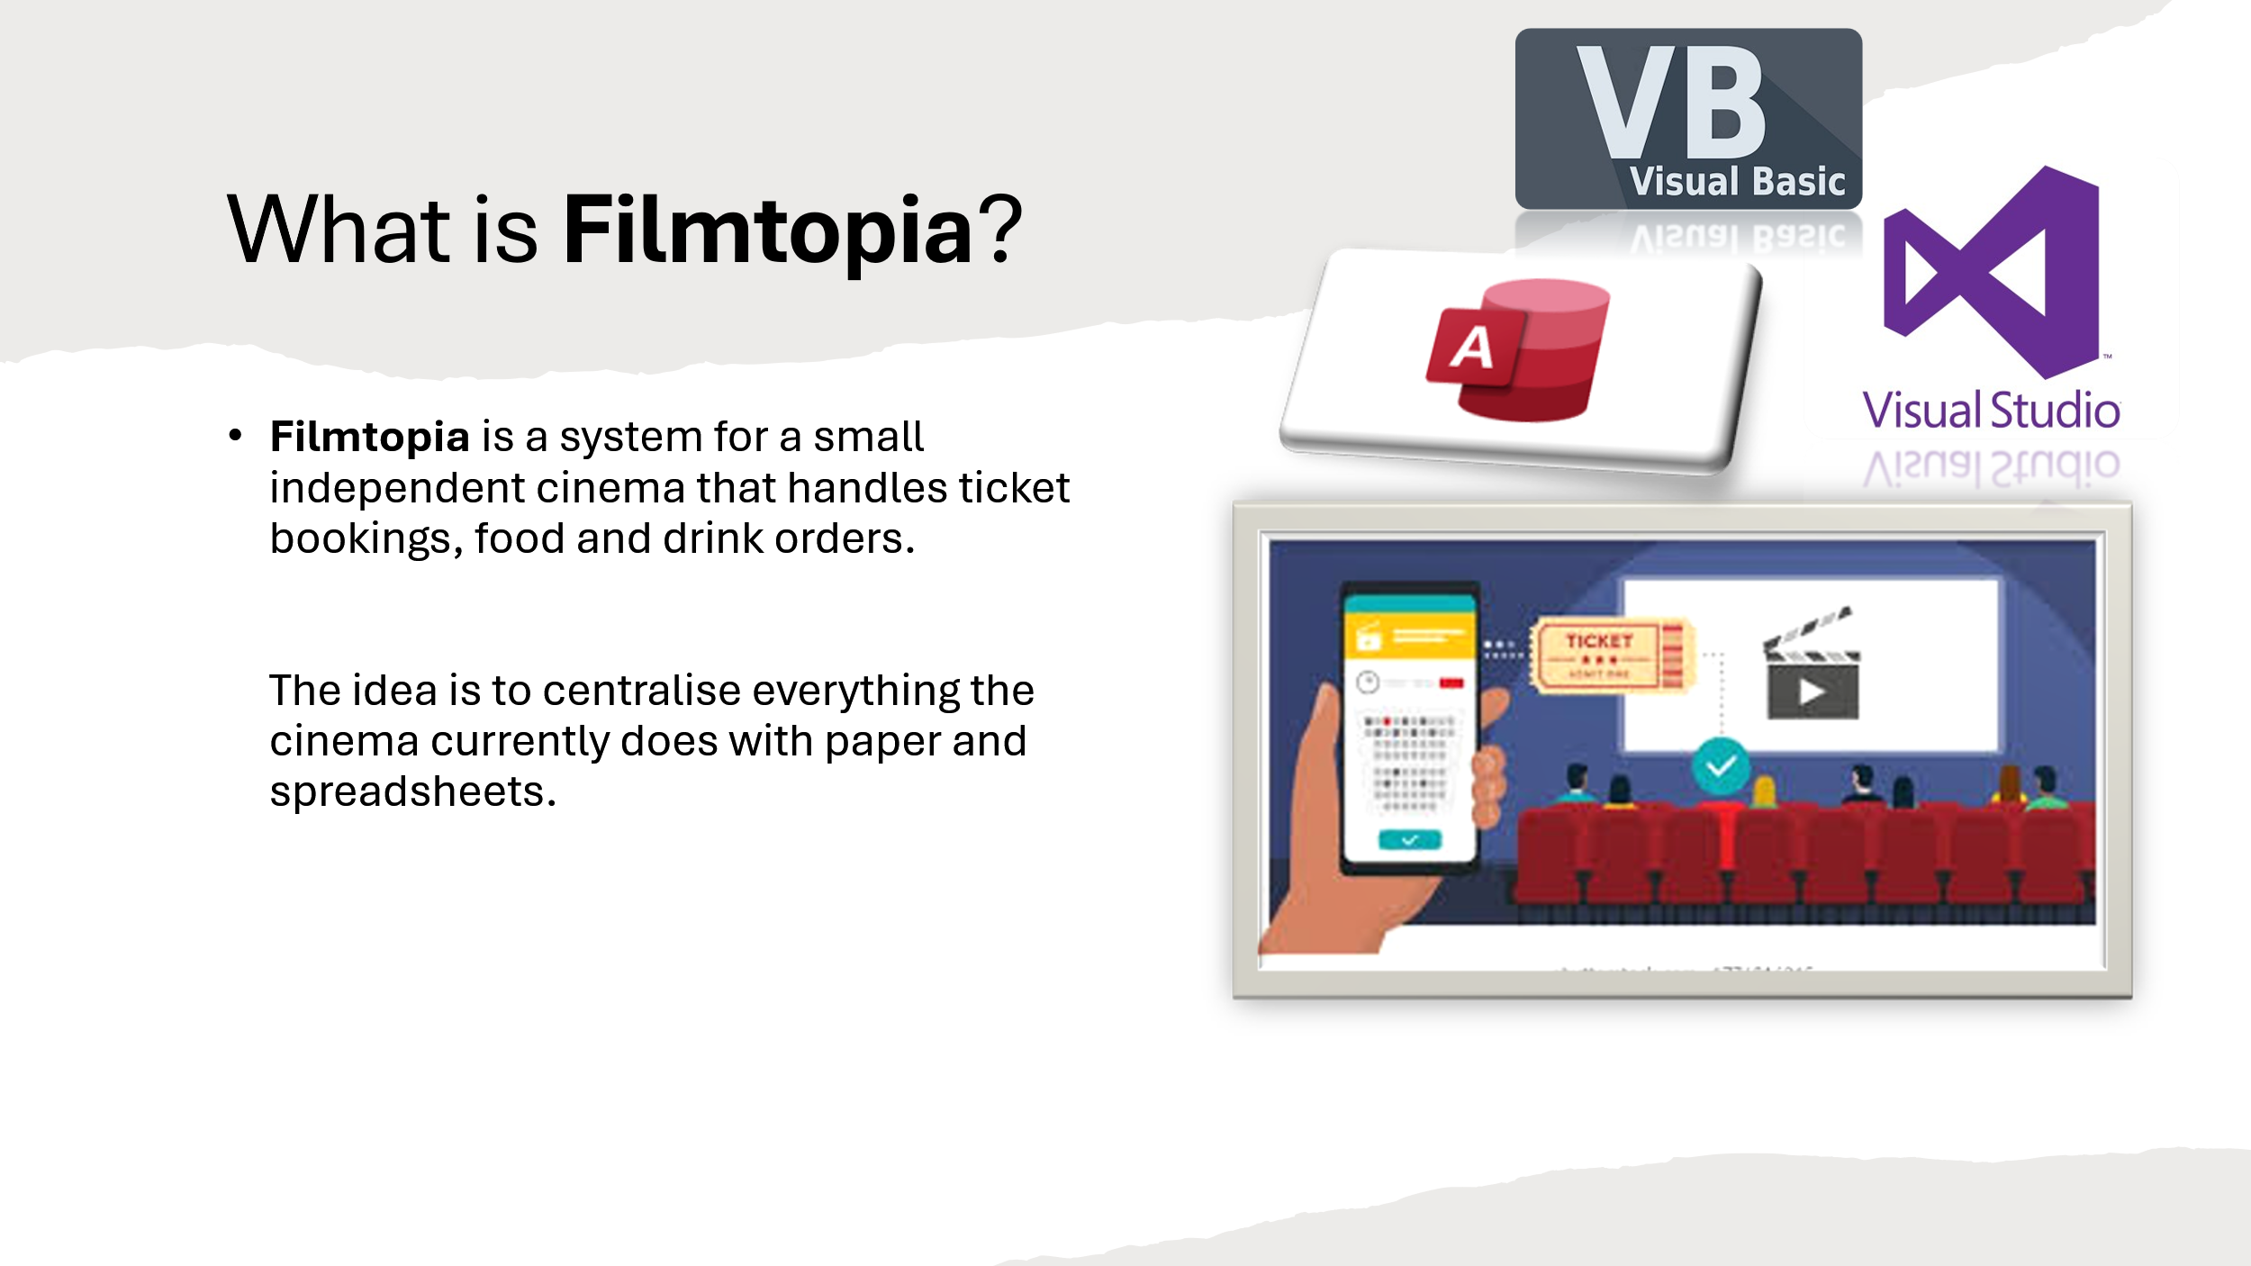
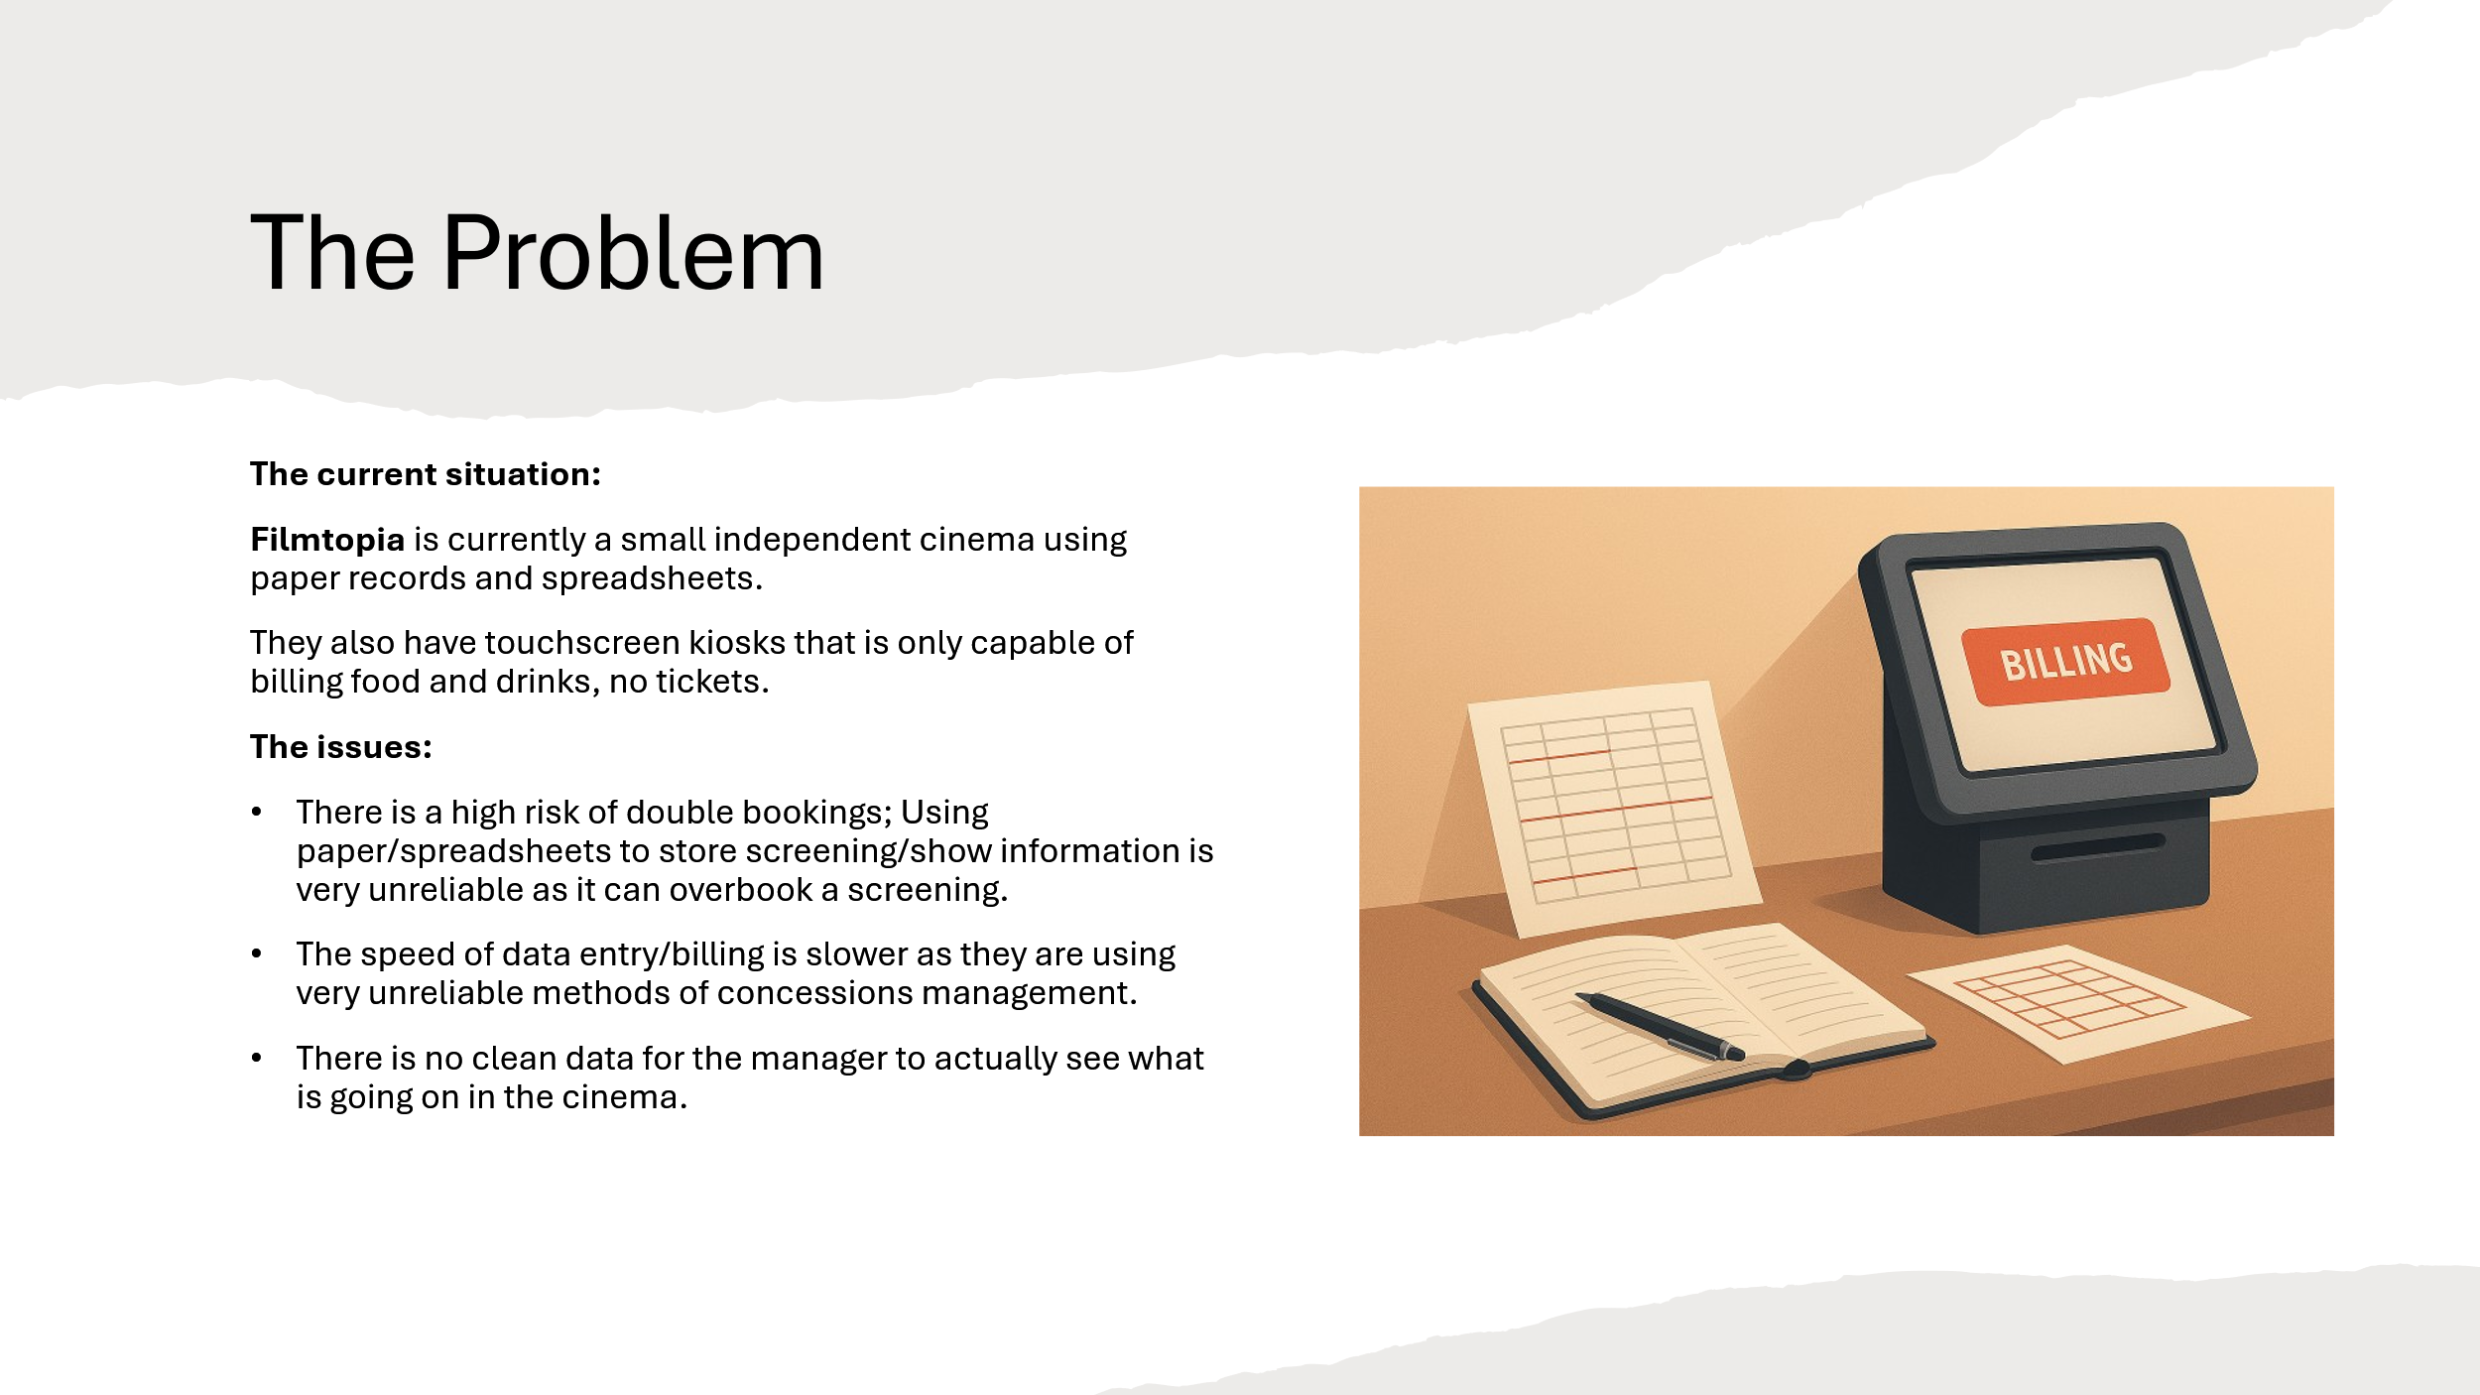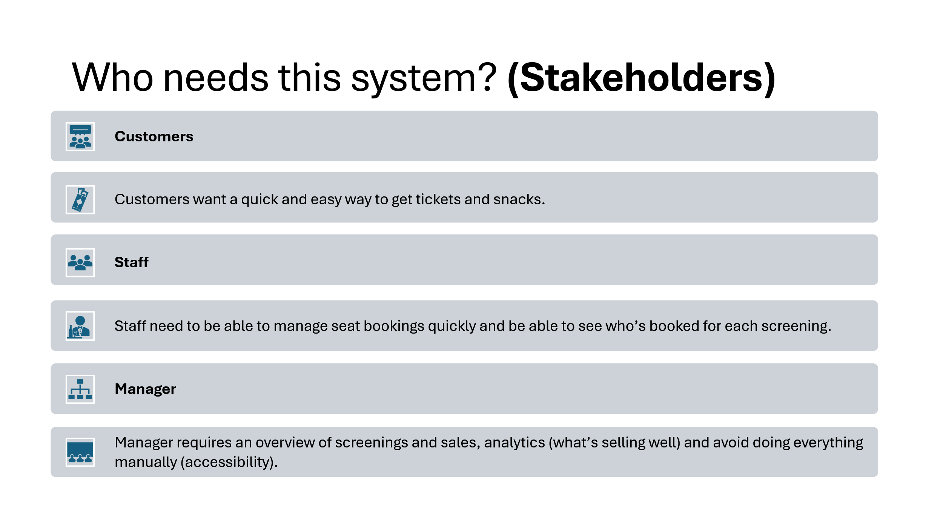
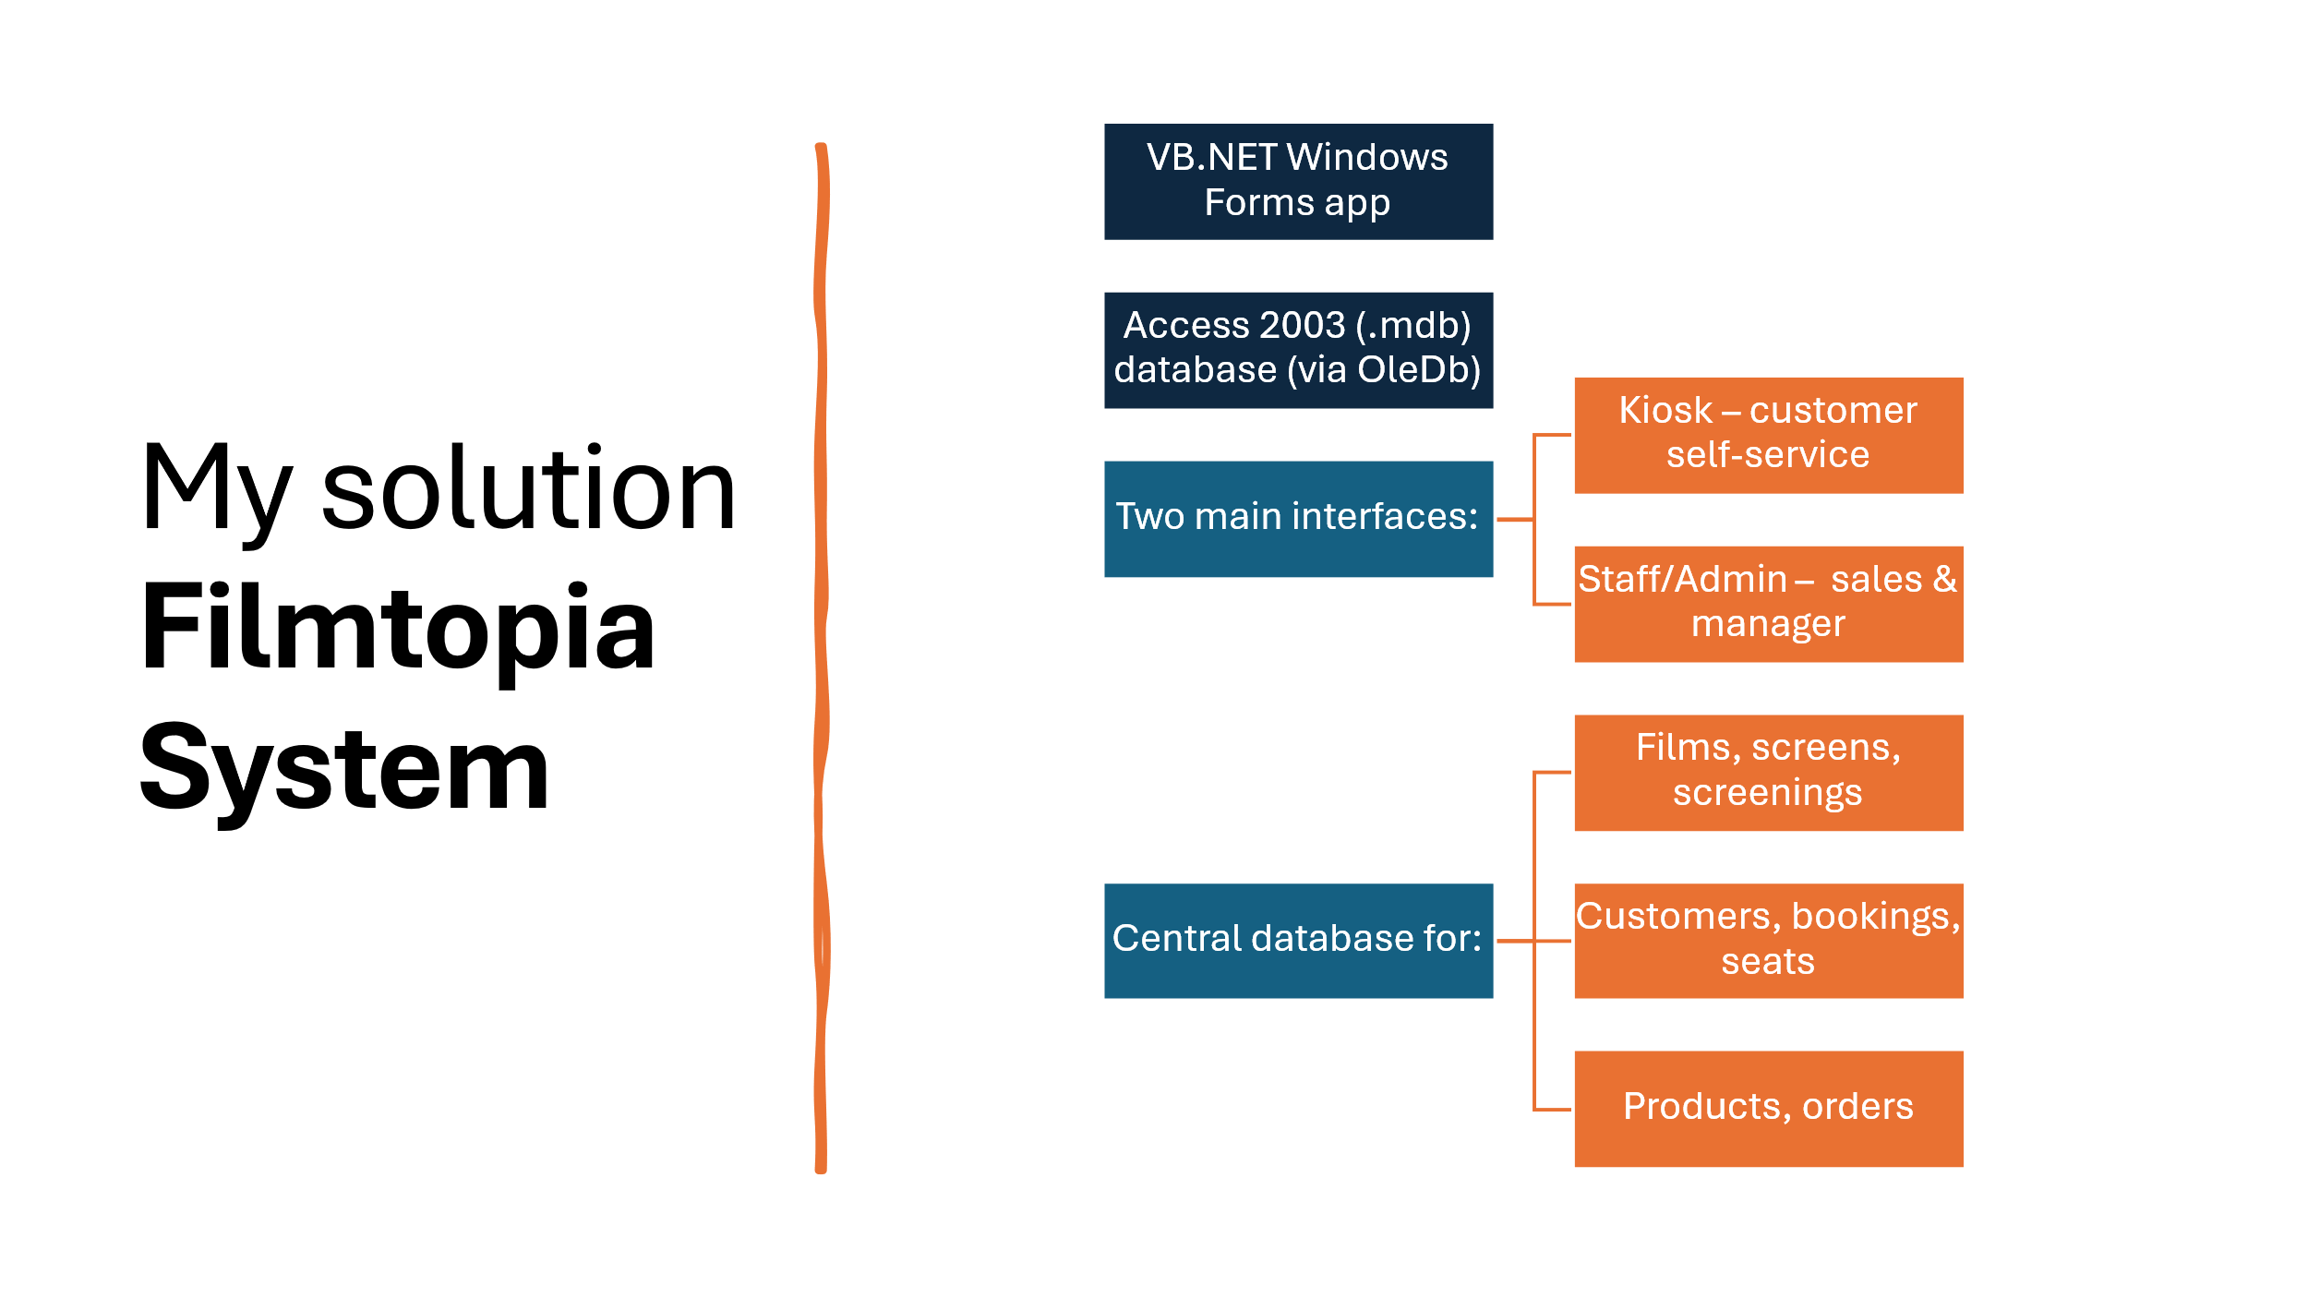
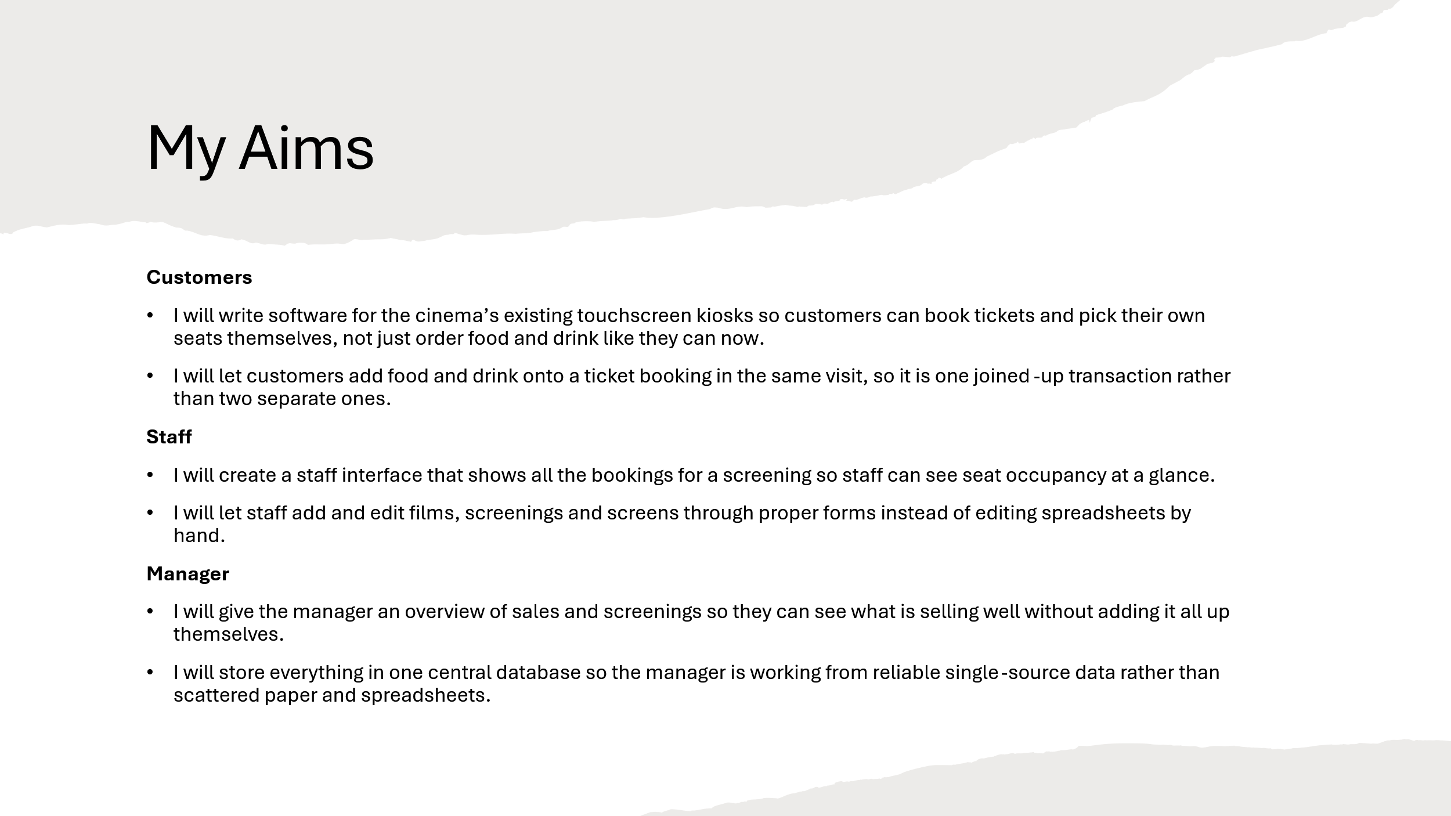
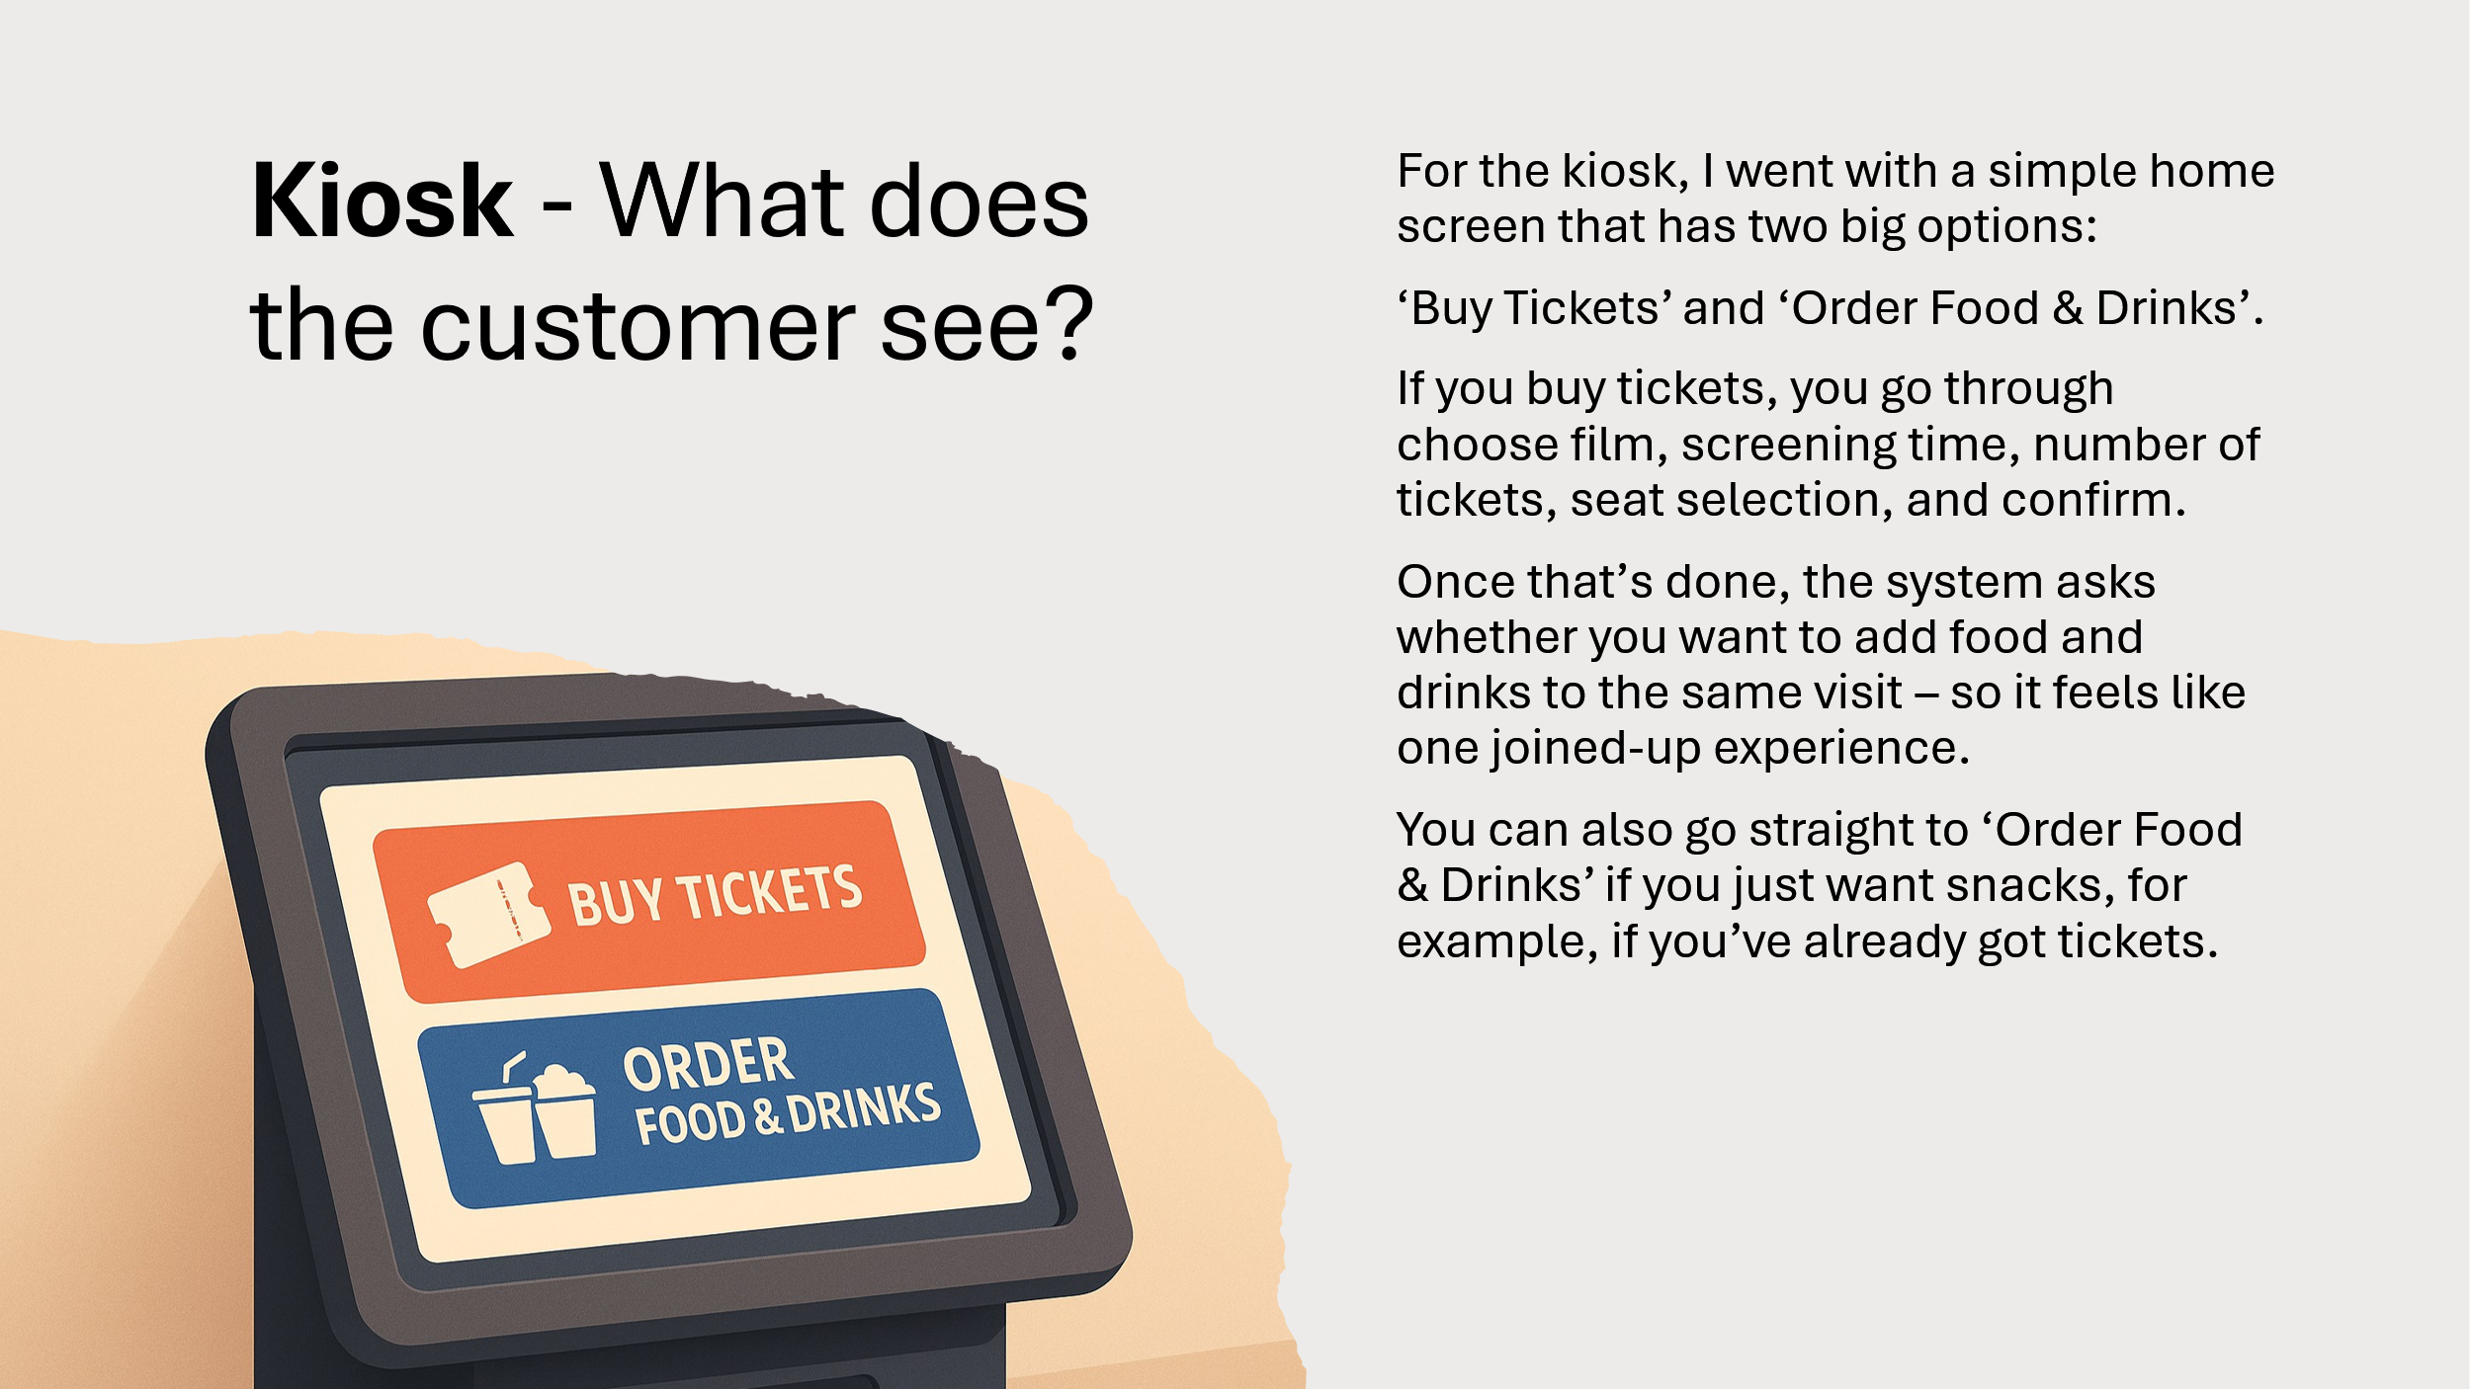
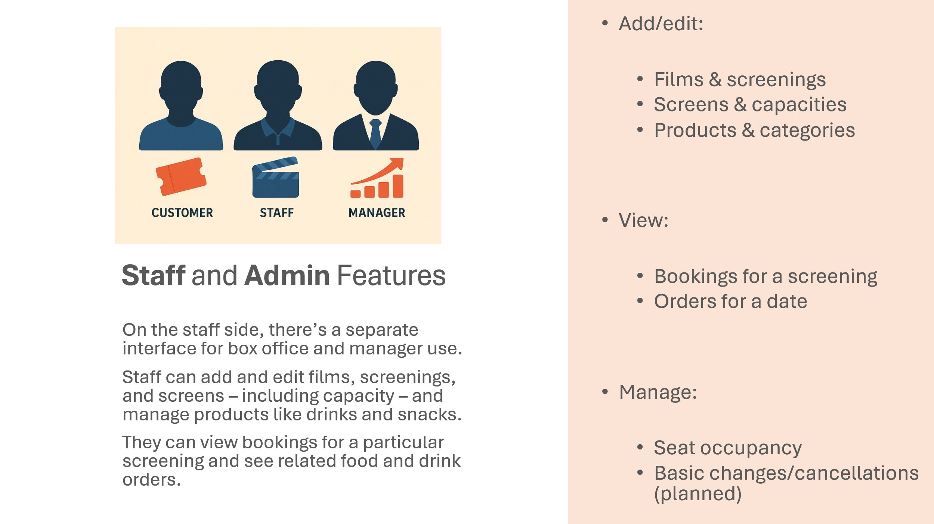
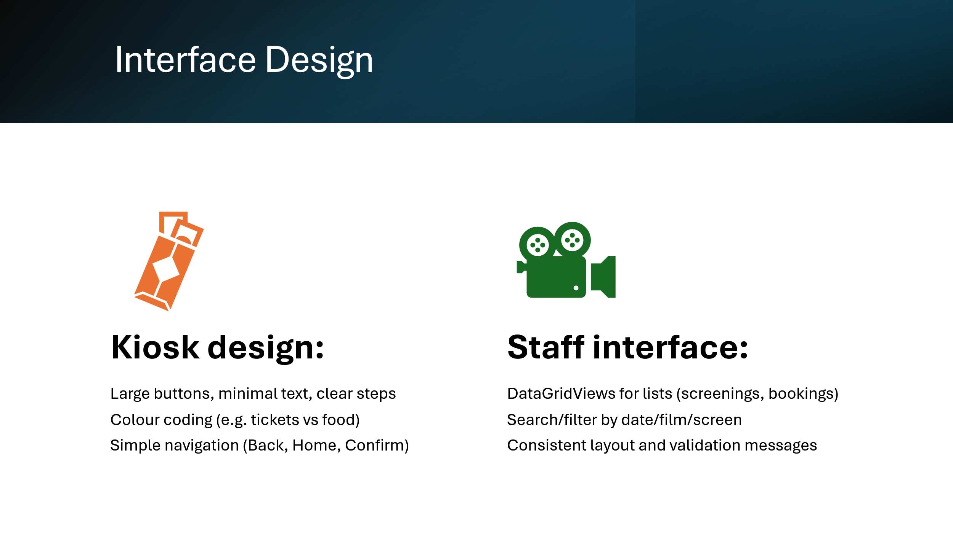
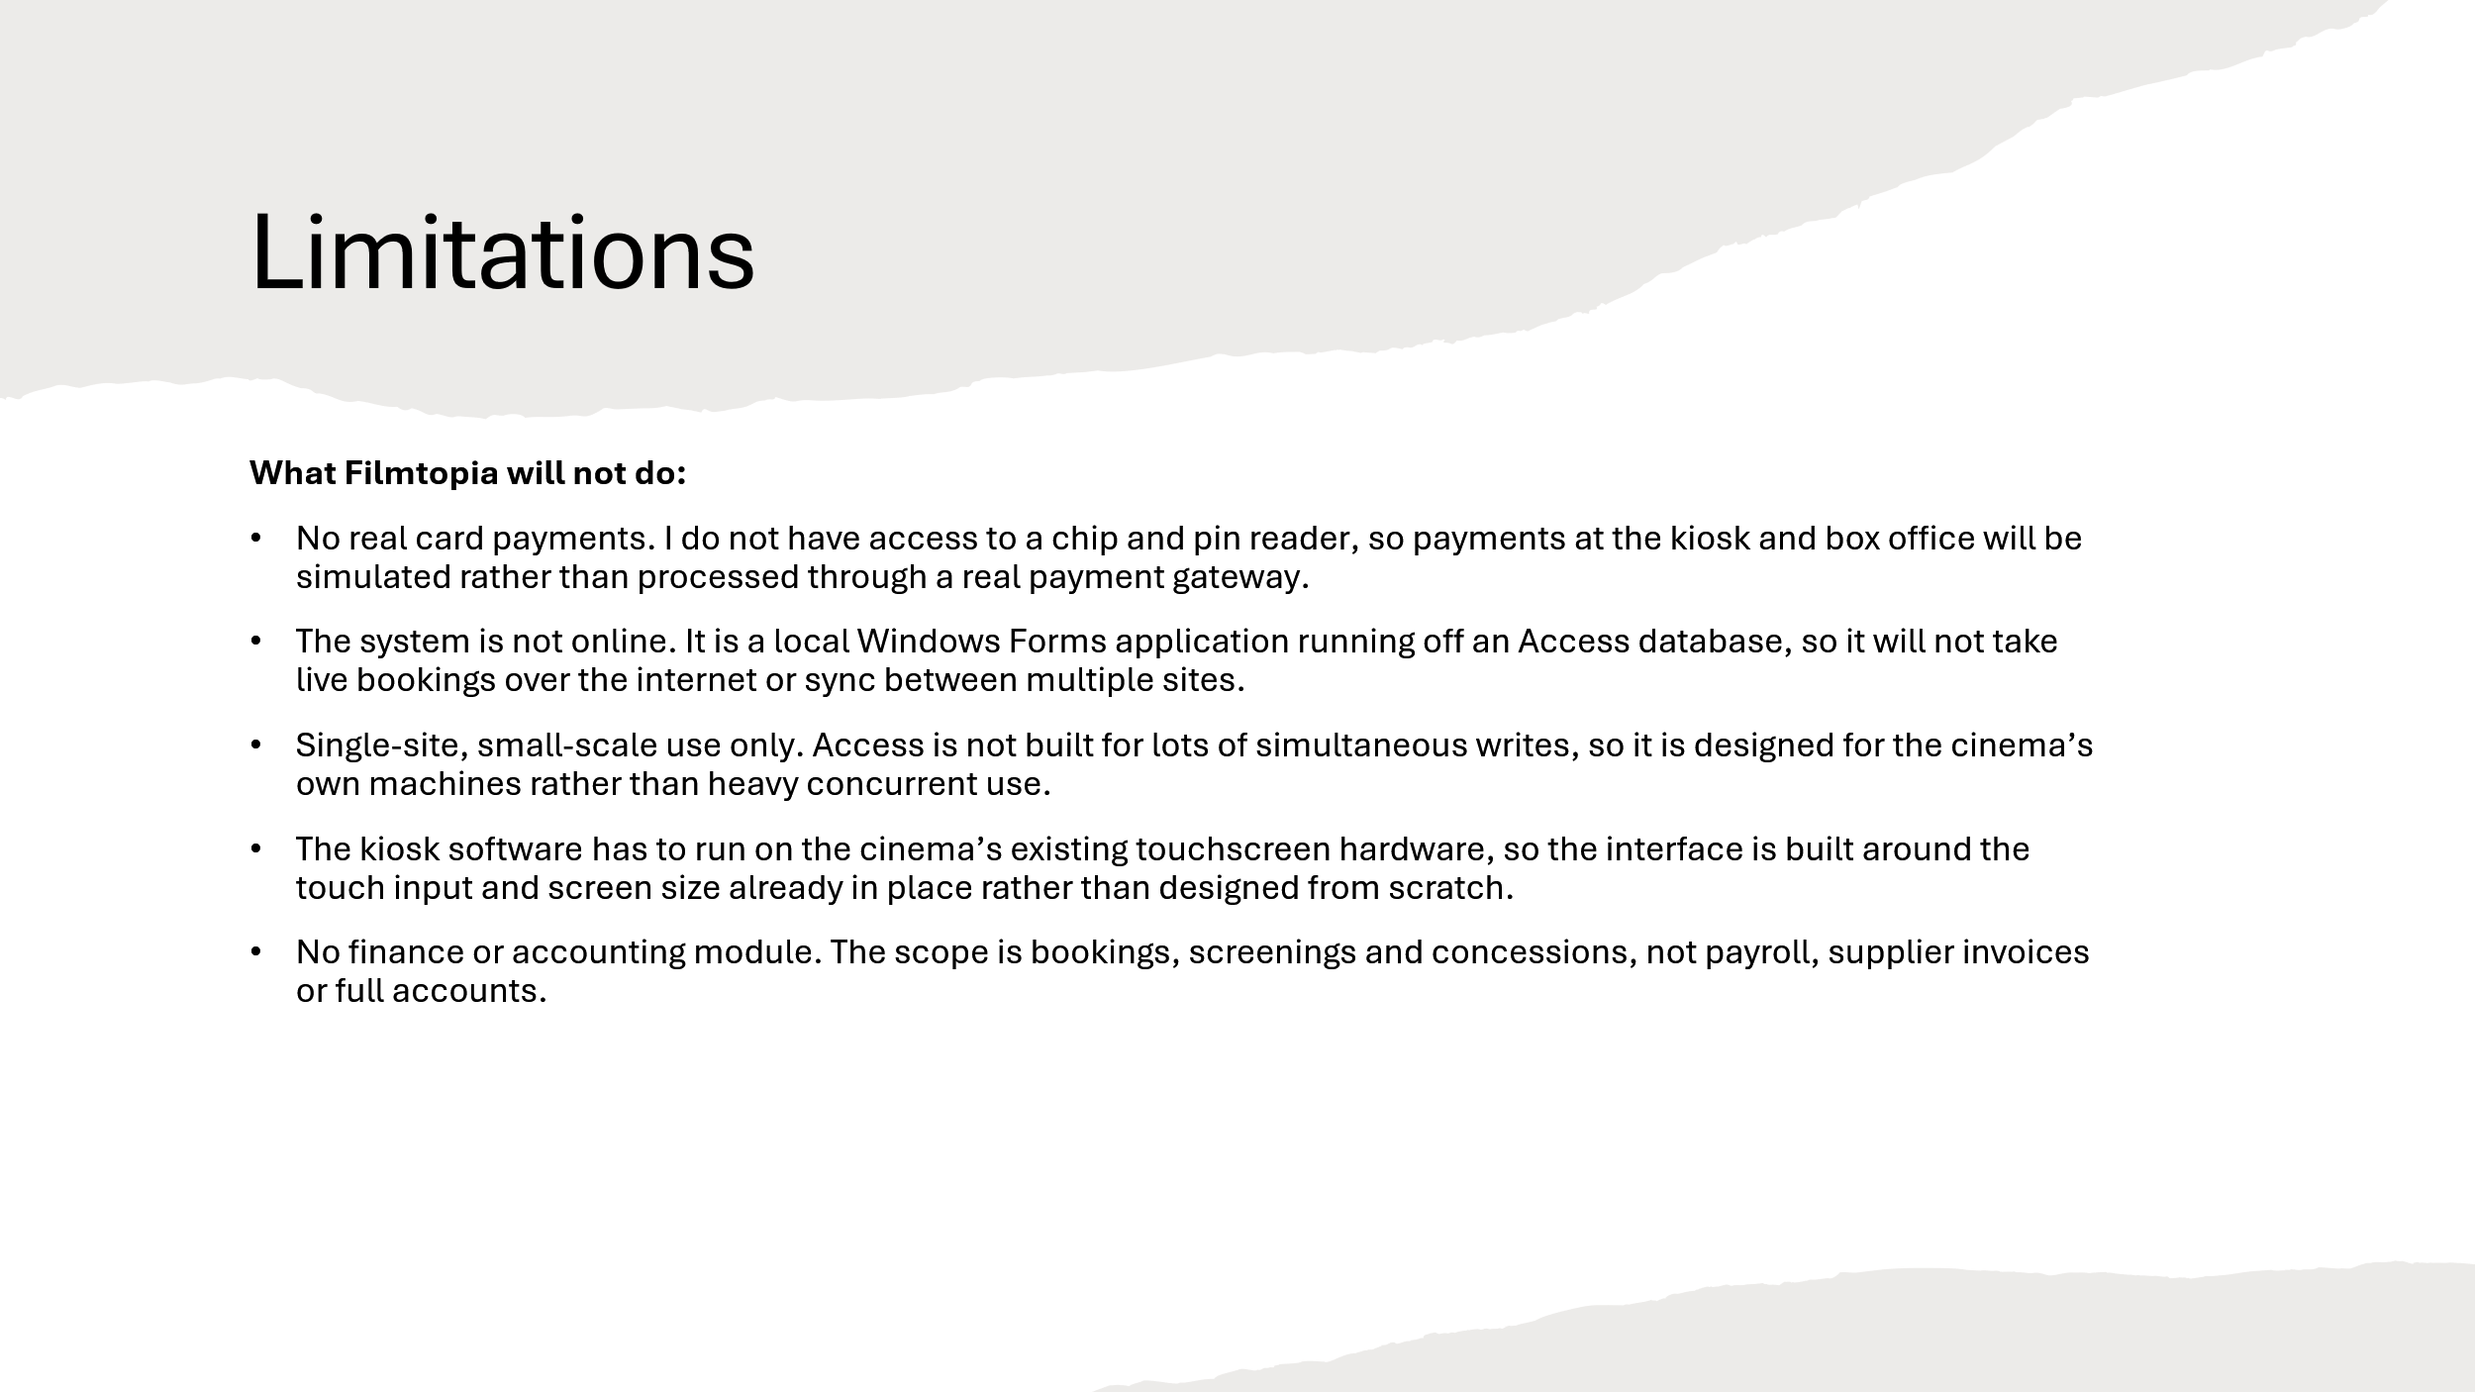

Feedback
After presenting the proposal I was asked a number of questions about the system. I have written each one down along with who it came from, and given a detailed response to each.
Q1 (from my teacher): Where will the data in your system actually come from, and how do you know it will be valid?
Most of the data gets entered by staff through the management forms rather than coming in from anywhere external, so the films, screenings, screens and products are all set up by a member of staff before customers ever see them. Because of that, the main risk is not bad external data, it is typos at entry, so I am validating everything as it goes in. For example a screening cannot be saved without a valid film and a valid date, and prices have to be a number rather than text. The customer-facing side of the kiosk does not let people type free text into things like seat numbers either, they pick from what the system offers, so there is no real way to enter something invalid.
Q2 (from my teacher): You keep mentioning double bookings as the main problem. How does your system actually stop two people booking the same seat?
This was the whole reason for moving off spreadsheets, so it is built right into how bookings work. Every screening has its own set of seats stored in the database, and a seat is tied to one screening only. When someone books, that specific seat for that specific screening gets marked as taken, so the next person simply is not offered it. Because the seats live in one central database rather than a spreadsheet that someone might have a stale copy of, there is no way for two people to grab the same seat for the same showing.
Q3 (Abraham, a classmate): Which people get to do what? It sounds like staff and managers are not the same thing.
They are not, and keeping them separate matters for security. The system has access levels, so a normal staff member and a manager log in to the same program but do not see the same things. Staff can do the day-to-day stuff like taking bookings and viewing who is coming to a screening, but the more sensitive options are hidden from them. A manager has a higher access level and can get to the things staff cannot, like setting up new screens or seeing the overview of sales. That way I am not trusting every single member of staff with everything, which is closer to how a real business would run it.
Q4 (Loui, a classmate): Setting up all the seats for every screen sounds like a nightmare to type in. How are you handling that?
I had the same worry, so I am not typing them in by hand. When a manager creates a screen, the system generates the seats for it automatically based on the capacity, laid out in rows so you end up with something like A1 to A10, B1 to B10 and so on. It means setting up a new screen is basically instant, and more importantly the seats are always created the same consistent way rather than relying on someone entering sixty rows correctly. It also keeps the seat data tidy, which is what makes the double-booking check reliable in the first place.
Q5(Lucas, a classmate): I can imagine that this project has a lot of ticket or concession transactions. How does your system expect to control the inflows and outflows of monetary transactions.
The system will not be able to manage real payments or card transactions. This is because they involve hardware such as card reader technology and/or any payment gateway APIs which are not in the scope of this project. Payment will be simulated to some extent within the system. However, the process of actually collecting money from the customer will be assumed to happen separately.
Q6(Max, a classmate): An employee makes an operational error during billing. How can the manager analyse the error?
I keep an audit log running behind every important action in the system, so a billing error does not just disappear once someone notices it. Every time a booking is created, cancelled or changed, the system records who did it and when, so if a customer or a manager flags something wrong, the manager can pull up the audit log for that booking and see exactly what was done and by which staff member. For example if a booking was set up with the wrong price or the wrong number of tickets, the manager can check the log rather than relying on staff remembering what happened during a busy shift. It also means staff know their actions are recorded, which should reduce careless mistakes happening in the first place.
Q7(Max, follow up question): If an employee does make an operational error during billing, How can the manager resolve the error?
Once the manager has found the mistake using the audit log, the system lets them process a refund against that booking rather than just deleting it and losing the record. The booking gets cancelled properly, and the refund amount is worked out automatically from what was originally charged for the tickets and any food and drink, so the manager is not doing that calculation by hand under pressure. The refund is then saved to the database with a timestamp, so there is a clear record of both the original error and how it was resolved. That way the mistake and the fix stay linked together rather than the booking just quietly vanishing.

Filmtopia Project Section 2: Investigation

Introduction
Filmtopia is a small independent cinema theatre who is currently managing all business data using spreadsheets and paper. They sell food drinks and tickets using a variety of means such as a touchscreen kiosk which can only handle food and drinks and a concessions area where employees handle the business. The management of Filmtopia has come to notice that they are falling back on managing and analysing the cinema, this means keeping track of sales records, screening analytics and a customer interest evaluation. I am now going to investigate further on how Filmtopia functions to get a better understanding of how I should move with this project.

Stakeholder Analysis
Before beginning the investigation it is important to identify who the stakeholders are for this project. A stakeholder is any individual or group who has an interest in the system, will be affected by it or has the power to influence how it is developed. Identifying stakeholders early on ensures that the requirements gathered throughout the investigation reflect the needs of everyone involved rather than just one person.
For the Filmtopia system the stakeholders can be split into two groups, primary and secondary. Primary stakeholders are those who will interact with the system directly on a regular basis. Secondary stakeholders are those who are affected by the system indirectly or whose work is influenced by it without them necessarily using it themselves.
Starting with the primary stakeholders, the most important of these is the cinema manager Sarah Henshaw. As the person who commissioned this project she has the highest level of influence over what the system needs to do. She will use the management side of the system on a daily basis, for example adding new films, scheduling screenings and viewing sales reports. Her main priorities are operational efficiency, accurate reporting and a reduction in the customer complaints that are currently caused by the manual booking process. She has described herself as tech aware but not highly technical which means the system needs to be intuitive enough to use without specialist knowledge or extensive training.
The next primary stakeholder group is the box office staff. These are the people who handle ticket sales and customer enquiries on a day to day basis and who will use the booking interface most frequently. Their priorities are speed and simplicity. During busy periods a member of staff cannot afford to spend several minutes navigating a complicated interface to add a single booking. The system therefore needs to be designed with efficiency in mind so that even a brand new member of staff could use it confidently with minimal training.
The third primary stakeholder is the customer base of Filmtopia. Customers interact with the system either directly through the proposed self service kiosk or indirectly when staff process their bookings on their behalf. Their main interests are convenience, short queue times and the assurance that the seat they have been allocated will actually be available when they arrive. The questionnaire results discussed later in this investigation show that a large majority of customers would prefer self service ticketing and that seat selection is considered important by most respondents. This means the bar for the kiosk interface is high and it needs to be clean and simple enough for any customer to use without assistance.
Moving on to the secondary stakeholders, the concessions team is worth considering here. Although they do not use the booking system directly the proposed solution will integrate food and drink ordering with ticket purchases which means orders placed through the kiosk will need to reach the concessions team accurately and in a timely manner. The current system of passing handwritten notes is described by staff as disjointed and prone to error so the new system needs to address this.
Another secondary stakeholder is any external IT support that Filmtopia uses. As a small independent cinema there is no dedicated IT department meaning the system must be robust and straightforward to maintain. Complex setups that require specialist knowledge to troubleshoot would be impractical for a business of this size.
In summary the stakeholder analysis makes clear that the Filmtopia system needs to serve a wide range of users with different levels of technical confidence and different priorities. The investigation that follows has been designed to gather requirements from as many of these stakeholders as possible to ensure the final system genuinely reflects the needs of everyone who will be affected by it.

Investigation Plan
The table below sets out the plan I followed to investigate the existing system. It lists each task, roughly how long it took, the method used and a short note on what the task was intended to achieve. The plan was put together so that the methods complement each other and so that every part of the existing system would be covered by the time the investigation was finished.
Task Description | Duration | Method | Comments
Initial meeting with client (Sarah Henshaw) to discuss project scope | 1 day | Face-to-face meeting | Establish what the client needs and agree on the direction of the project
Interview with cinema manager (Sarah Henshaw) | 1 day | Face-to-face interview | Gather detailed information about the existing system and requirements from a management perspective
Interview with box office staff member (Jake Pemberton) | 1 day | Face-to-face interview | Understand day-to-day operational problems from a staff perspective
Customer questionnaire design and distribution | 1 day | Paper questionnaire | Distribute to 20 cinema customers to gather end user requirements
Customer questionnaire analysis | 1 day | Data analysis | Summarise and interpret questionnaire responses
Direct observation of existing system | 1 day | Observation | Observe box office operations during a live evening screening
Examine existing records and documents | 1 day | Document inspection | Look at the paper booking diary, stock and rota spreadsheets and ticket stub to see what data is actually captured
Desk based research - Vue Cinema (myvue.com) | 1 day | Online research and screenshots | Analyse features of a professional existing cinema booking system
Desk based research - Odeon Cinema (odeon.co.uk) | 1 day | Online research and screenshots | Compare a second professional system and identify additional features
Data flow diagram - existing system | 2 days | Diagram | Produce a DFD showing how data moves through the current paper based system
Overview of existing system | 2 days | Written analysis | Document inputs, outputs, processing and limitations of the current system
Problem definition | 1 day | Written analysis | Clearly define the core problems the proposed solution must address
Limitations of proposed solution | 1 day | Written analysis | Identify what the system will not include and explain why
Objectives and evaluation criteria | 2 days | Written analysis | Produce 15 numbered objectives each with a measurable success criteria

Methodology for Investigating
Before carrying out the investigation it is important to think carefully about which methods to use to gather information. Different methods have different strengths and weaknesses and relying on just one would not give a complete enough picture of the existing system or what the new one needs to do. For this investigation the methods chosen were face-to-face interviews, a customer questionnaire, direct observation, an examination of the records and documents the cinema uses and desk based research.
Starting with interviews, these were chosen as the main method for gathering requirements from the key stakeholders. The reason for this is that an interview allows open ended questions to be asked and the conversation can naturally go in directions that were not planned in advance. This is important because some of the most useful information gathered during an investigation comes from things that the person being interviewed mentions without being directly asked. A written survey would not allow for this kind of flexibility. The limitation of interviews however is that they are time consuming and the quality of what comes out of them depends heavily on how well the questions are prepared. To address this the questions were written in advance and kept open ended to avoid leading the person being interviewed towards a particular answer. Two interviews were conducted for this investigation, one with the cinema manager and one with a member of the box office staff, as these two stakeholders gave the most complete view of how the existing system operates day to day.
Moving on to the customer questionnaire, this was chosen because it allowed a much larger group of stakeholders to contribute to the investigation than would have been possible through interviews alone. Interviewing every customer individually would not be realistic, so a questionnaire was the most practical way to gather their views. The key advantage of a questionnaire is that it produces quantitative data which is easier to summarise and use as justification for design decisions. For example knowing that a large majority of customers would prefer a self service kiosk is a much stronger argument for including that feature than one person mentioning it in an interview. The limitation of a questionnaire is that the questions are fixed which means there is no opportunity to follow up on responses or ask for more detail. To partially work around this some of the questions included a list of options rather than just a yes or no answer which produced more useful and specific data.
Transitioning to direct observation, this was included because interviews and questionnaires rely on people describing the system from memory which is not always accurate. Watching the system being used in real time makes it possible to see problems that the people involved might not even be aware of because they have become used to working around them. The observation was carried out during a busy evening period deliberately, since the existing system's weaknesses are most likely to show up under pressure rather than during a quiet period. The main limitation of observation is the Hawthorne Effect, which is the tendency for people to change their behaviour when they know they are being watched. This was minimised by keeping the observation as low key as possible.
I also examined the actual records and documents the cinema relies on, such as the paper booking diary and the spreadsheets used for stock and staff rotas. Looking at the real paperwork was worthwhile because it shows exactly what data is being captured at the moment rather than what people remember being captured, and it tends to reveal small but important details that nobody thinks to mention in an interview because they are so used to them.
Finally, desk based research was used to look at how similar systems are designed in the real world. By researching the booking systems of established cinema chains it is possible to identify features and design patterns that set the standard for what customers already expect. This is useful because stakeholders do not always know what to ask for, particularly if they have not seen what is possible. The limitation of this method is that the systems being researched are built by large commercial teams with significant resources, so not everything observed will be feasible within the scope of this project. The research has therefore been used to inform and inspire the design rather than to copy it directly.
The reason all of these methods were used together is that each one compensates for the weaknesses of the others. Interviews provide depth, the questionnaire provides breadth, observation and the documents provide real world evidence and desk based research provides industry context. Where the same issue or requirement appears across multiple methods it can be treated with much greater confidence than if it had only come from one source.

Investigation

Interviews

Interview with Sarah Henshaw - Cinema Manager
Q: Can you describe how Filmtopia currently manages its ticketing and bookings?
A: At the moment everything is done manually. When a customer comes in, staff write their booking down in a paper diary. We have a touchscreen kiosk but it can only handle food and drink orders. It cannot sell tickets at all which is a real problem during busy periods because customers have to queue twice.
Q: What are the biggest problems you face with the current system?
A: Double bookings are a nightmare. Because everything is written on paper, if two members of staff take a booking for the same screening at the same time we do not find out until the customer arrives. We have had some very unhappy customers because of this. Also I have no real way of seeing how well the cinema is doing without physically going through every piece of paper we have.
Q: What data does Filmtopia currently store and how?
A: We keep a paper diary for bookings, a spreadsheet for staff rotas and another spreadsheet for food and drink stock. None of these connect to each other. If I want to know how many tickets we sold for a particular film last month I have to manually count through pages of handwritten notes.
Q: What would you most want a new computerised system to do?
A: The most important thing for me is being able to see everything in one place. I want to know how many seats are available for any screening at a glance, see sales figures without digging through paperwork and be able to add new films and screenings quickly and easily. I also want customers to be able to buy tickets through the kiosk rather than having to come to the desk.
Q: Who would be using this system on a day to day basis?
A: Mainly the box office staff and myself. The staff need something simple that they can use quickly during busy periods. They cannot be spending five minutes trying to figure out how to add a booking. I would need a separate manager view where I can see reports and make changes to the system that staff should not be able to access.
Q: Are there any constraints we should be aware of?
A: Budget is tight as we are an independent cinema so whatever is built needs to run on our existing computers. We are also only a small team so the system needs to be genuinely easy to use without much training.

Interview with Jake Pemberton - Box Office Staff Member
Q: Can you describe what your typical working day looks like at the box office?
A: It is pretty hectic on weekends. Customers come up to buy tickets, we check the paper diary to see if there are seats available, write down their details, take payment and give them a ticket stub we print from a template. During busy periods there can be a queue of ten or more people and it gets really stressful trying to manage everything manually.
Q: What problems do you regularly run into with the current system?
A: The biggest one is not knowing if a seat is already taken. Sometimes a customer picks a specific seat and we say yes, then another member of staff has already given that seat to someone else and we do not know until they both turn up. It causes a lot of awkward situations. Also finding information takes too long. If someone asks what time a film starts or how many seats are left I have to physically look through the diary.
Q: How do you currently handle food and drink orders alongside ticketing?
A: They are completely separate which makes no sense. The kiosk handles food and drinks but not tickets so a customer might queue at the kiosk for snacks and then have to queue again at the desk for their ticket. If they want to order food to be brought to their seat during a screening that is done on a notepad and passed to the concessions team. Nothing is joined up.
Q: What would make your job easier?
A: Something on a screen that shows me exactly which seats are taken and which are free for any screening. Being able to add a booking in a few clicks rather than writing it all down. It would be great if food orders could be linked to a ticket booking so everything is in one place.
Q: Do you have any concerns about moving to a computerised system?
A: As long as it is straightforward to use I am fine with it. I am not very technical so if it is complicated I will struggle during busy periods. It needs to be quick. I cannot be spending ages clicking through menus when there is a queue of people waiting.

Questionnaire
A questionnaire was distributed to customers visiting Filmtopia in order to gather feedback on their experience with the current system and to understand what they would want from a new one. It was administered on the 15th of January 2026 as a paper questionnaire handed to customers at the cinema, and 20 responses were collected. The questions and summarised responses are as follows.
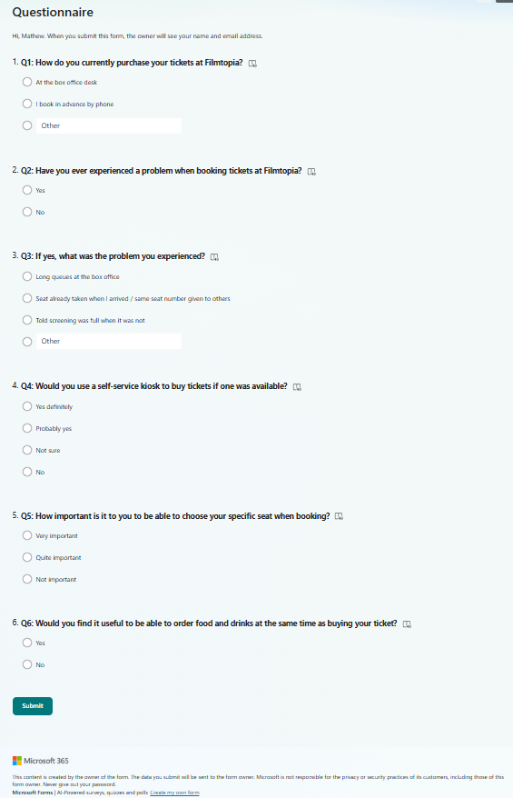

Q1: How do you currently purchase your tickets at Filmtopia?
Response | Number of Customers
At the box office desk | 14
I book in advance by phone | 4
Other | 2

The majority of customers purchase tickets directly at the box office. No customers reported being able to book online or through a kiosk which confirms that the current system offers very limited options for customers.

Q2: Have you ever experienced a problem when booking tickets at Filmtopia?
Response | Number of Customers
Yes | 13
No | 7

65% of customers reported experiencing a problem. This is a significant finding and strongly supports the need for a new system.

Q3: If yes, what was the problem you experienced?
Problem | Number of Customers
Long queues at the box office | 9
Seat already taken when I arrived / same seat number given to others | 5
Told screening was full when it was not | 3
Other | 2

Long queues and seat allocation errors were the most commonly reported problems. These directly reflect the issues raised by Sarah Henshaw and Jake Pemberton in their interviews.

Q4: Would you use a self-service kiosk to buy tickets if one was available?
Response | Number of Customers
Yes definitely | 12
Probably yes | 5
Not sure | 2
No | 1

85% of customers indicated they would use a self-service kiosk for tickets. This strongly justifies the inclusion of a customer-facing kiosk interface in the proposed system.

Q5: How important is it to you to be able to choose your specific seat when booking?
Response | Number of Customers
Very important | 11
Quite important | 6
Not important | 3

85% of customers felt seat selection was at least quite important. This supports the planned graphical seat selection feature in the Filmtopia system.

Q6: Would you find it useful to be able to order food and drinks at the same time as buying your ticket?
Response | Number of Customers
Yes | 16
No | 4

80% of customers would find combined ticketing and food ordering useful. This confirms that integrating food and drink ordering with ticket booking is a worthwhile feature.

Summary of Questionnaire Findings
The questionnaire results clearly show that customers are experiencing real problems with the current system at Filmtopia. The most significant issues are long queues at the box office, errors with seat allocation and the inability to book tickets through the kiosk. The results also show strong demand for a self-service ticketing kiosk, graphical seat selection and combined food and drink ordering. These findings have directly informed the objectives set out later in this investigation.

Direct Observation
As part of the investigation I visited Filmtopia during an evening showing to observe how the current system operates in practice. Rather than asking questions or interrupting the workflow I simply watched how staff handled customers during the pre-screening period when the cinema was at its busiest. The aim was to see the existing system in action and to identify any problems that might not have come up during the interviews or questionnaire.
The first thing that stood out was how the paper booking diary was being used by two members of staff at the same time. On more than one occasion both staff members reached for the diary simultaneously to check seat availability for the same screening. This caused a brief but noticeable delay in serving customers and illustrated exactly the kind of risk that the interviews had described, where two staff members could independently assign the same seat without either realising.
It was also clear that customers who had already used the kiosk to order food and drinks were then joining the box office queue to buy their tickets separately. This meant some customers were effectively queuing twice before they could take their seat. During the observation period this happened repeatedly and on a couple of occasions customers waiting in the box office queue made comments about having already waited at the kiosk. This confirmed what the staff interviews had suggested about the kiosk and ticketing systems being completely disconnected from each other.
Another thing worth noting was how long it took a staff member to answer a simple question about seat availability. When a customer asked which seats were still free for a particular screening the staff member had to manually look through several pages of the diary before being able to give an answer. This took around 90 seconds and caused the queue behind that customer to grow noticeably during that time. In a busier cinema this kind of delay would quickly become a serious problem.
Overall the observation confirmed and added detail to the problems that had already been identified through the interviews and questionnaire. Seeing the existing system in action made it clear that the issues are not occasional or minor but are a regular feature of how the cinema operates during busy periods. The findings from this observation have directly informed the objectives set out later in this investigation.

Records and Documents Examined
Alongside the interviews, questionnaire and observation I also asked to look at the actual records and documents that the cinema uses day to day. Looking at the real paperwork is useful because it shows exactly what data is being captured at the moment, and it often reveals small details that nobody thinks to mention in an interview simply because they are so used to them. Four documents were examined and each one is described below.

The Paper Booking Diary
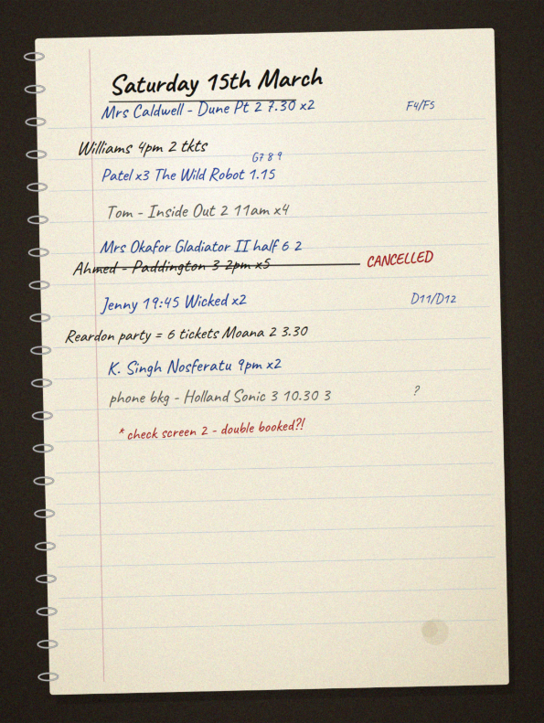
The first document I examined was the paper booking diary. Each day is given its own page and bookings are written in by hand as customers arrive, with the customer name, the film, the screening time and the number of tickets noted down, and a seat number sometimes squeezed into the margin. There is no fixed structure to how a booking is recorded, so the level of detail varies from one entry to the next depending on which member of staff took it. This immediately showed me why seat clashes happen, because there is no clear column or layout showing which seats have already gone for a particular screening, so a member of staff has no quick way of checking before promising a seat to a customer.

The Food and Drink Stock Spreadsheet
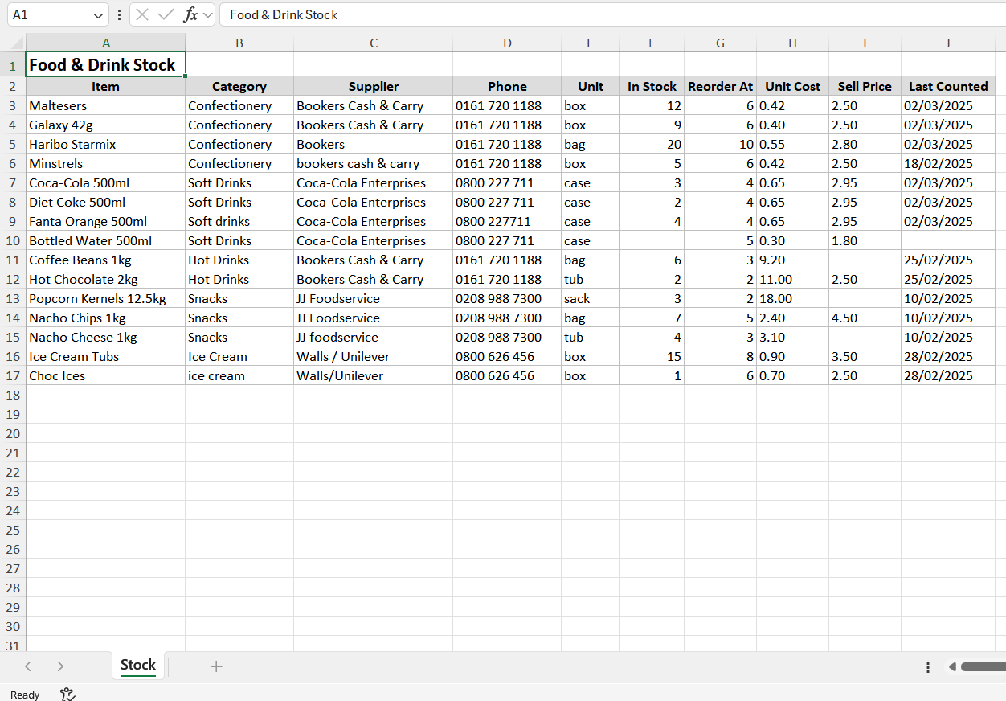
The second document was the spreadsheet used to track food and drink stock. It lists each item alongside a quantity that the manager updates by hand after a manual stock count. Because the figures are only correct as of the last time someone counted, the spreadsheet is rarely an accurate picture of what is actually in the building, and nothing about it is linked to what gets sold at the concessions area or the kiosk. Seeing it confirmed how disconnected the stock side of the business is from everything else.

The Staff Rota Spreadsheet
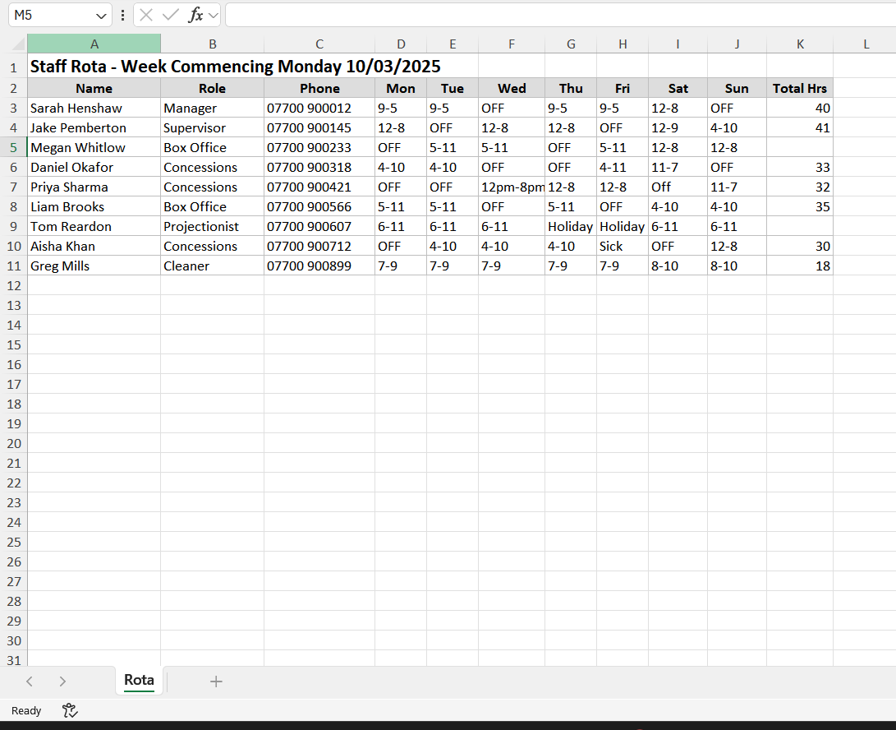
The third document was the staff rota spreadsheet, which the manager fills in and prints out for the team. It is kept completely separate from the booking and stock records, and the only way for a member of staff to check when they are working is to be physically at the cinema where the printout is pinned up. While staff scheduling is not a core part of the problem this project is solving, looking at the rota helped confirm just how scattered the cinema's information is across separate files that do not talk to each other.

The Ticket Stub
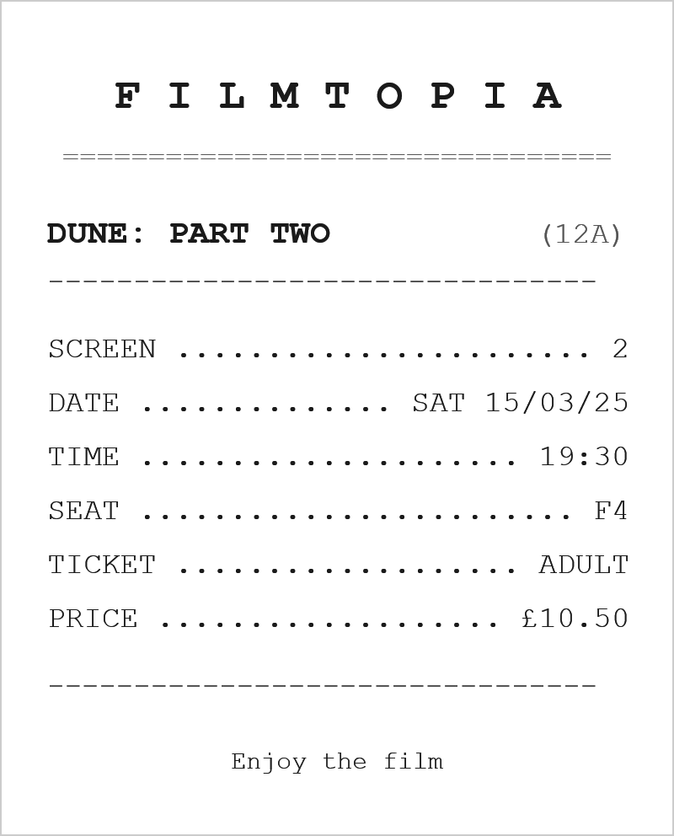
Finally I looked at the ticket stub that customers are given when they book. It is printed from a basic template on the box office computer, and a member of staff types the details in by hand each time before printing. The stub is not connected to any stored record, so once it has been printed there is no link between the piece of paper the customer is holding and any data the cinema keeps. This means a lost or disputed ticket cannot easily be checked against anything, which is another consequence of there being no central record of bookings.
Taken together these documents painted a clear picture of a business whose data lives in several separate places, none of which are joined up. This directly supports the case for a single central database made later in this investigation, and it reinforces the double booking problem that the seat handling in Objectives 2 and 3 is designed to solve.

Desk-based Research

Desk Based Research - Vue Cinema (myvue.com)
As part of my investigation I researched the Vue Cinema booking system, which is one of the largest cinema chains in the UK. Vue operates 94 cinemas across the UK and Ireland and their online booking system provides a useful reference point for what a professional cinema management system should look like.
Film Listings Page
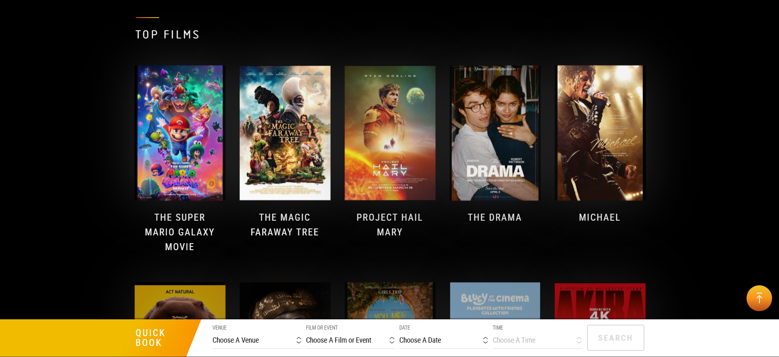
Vue film listings page (myvue.com)
The Vue homepage presents films visually using large poster images organised under a Top Films heading. Each film is displayed with its title clearly beneath it and the page includes a Quick Book bar at the bottom allowing users to search by venue, film, date and time simultaneously. This is a clean and intuitive way of presenting information that allows customers to find what they want quickly without having to navigate through multiple pages. For the Filmtopia system I will incorporate a similar visual approach to displaying films on the customer kiosk, ensuring that screenings are easy to browse and select.
Screening Times Page
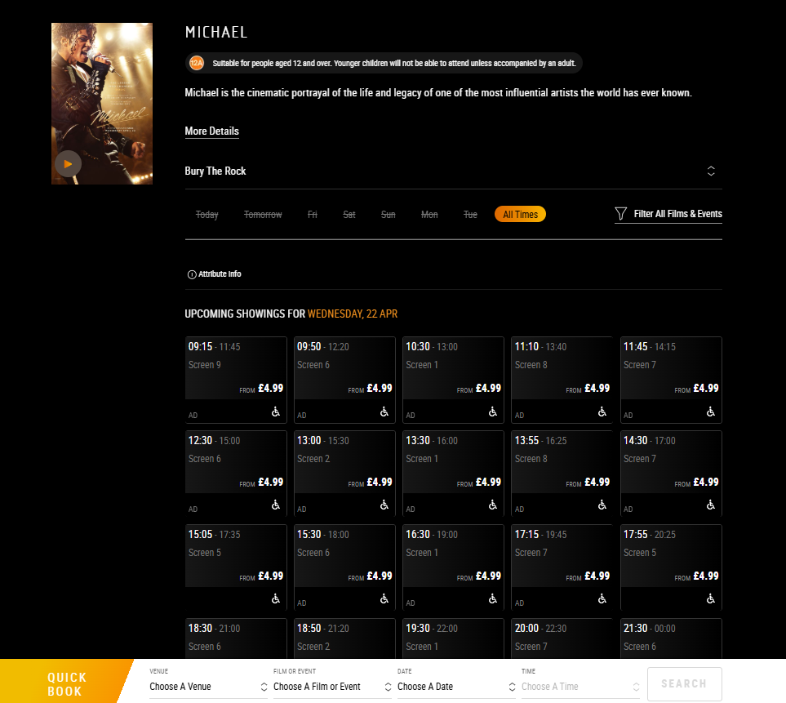
Vue screening times page (myvue.com)
When a film is selected Vue displays all upcoming showings for that film at the chosen venue, organised by date and time. Each screening card shows the start and end time, the screen number and the ticket price. Accessibility information such as audio description and wheelchair access is also clearly displayed. This level of detail is something I aim to replicate in Filmtopia, where staff and customers should be able to see all relevant information about a screening at a glance without having to search through multiple menus.
Seat Selection Screen
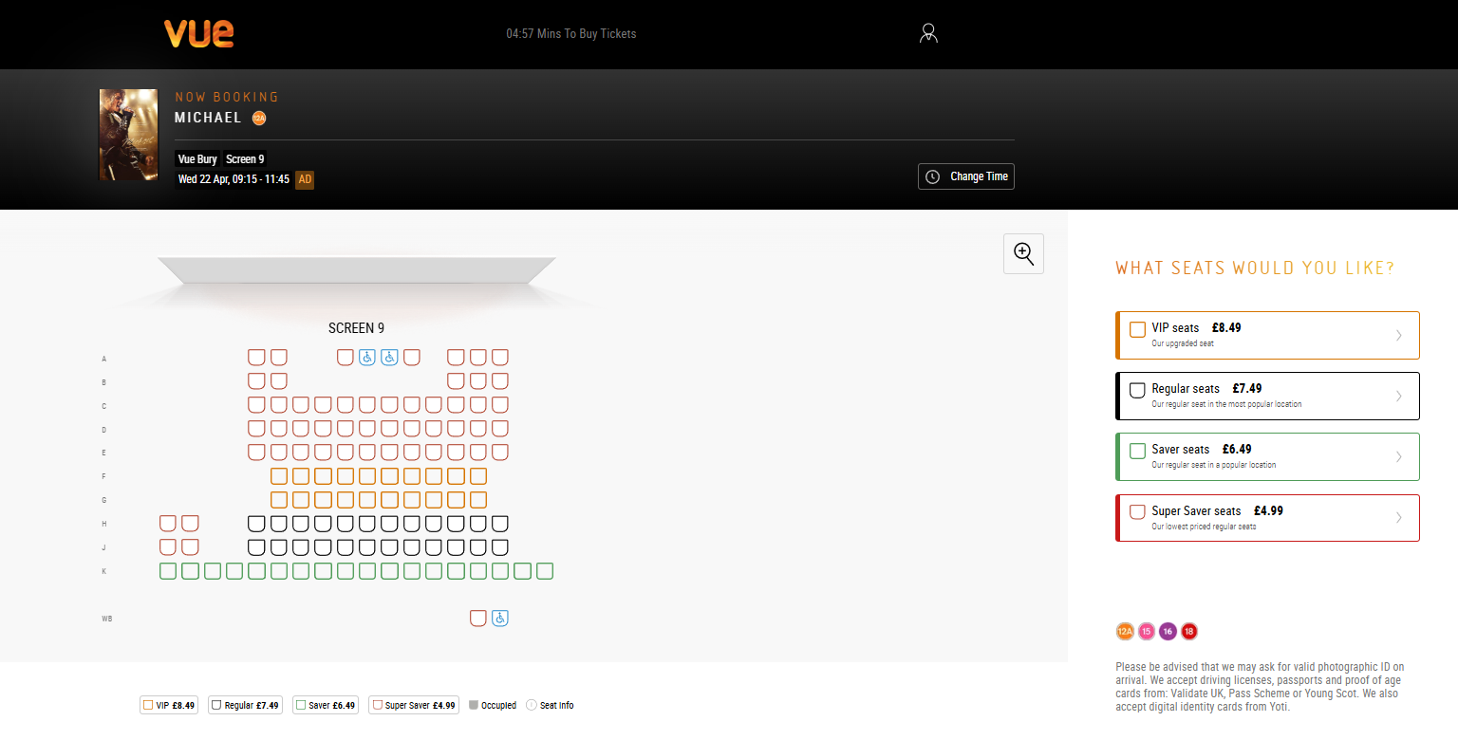
Vue graphical seat selection screen (myvue.com)
Vue's seat selection interface is a standout feature of their system. It displays a graphical layout of the screen showing every seat as a coloured icon, with different colours representing different seat types and prices. VIP seats are shown in orange at £8.49, Regular seats in black at £7.49, Saver seats in green at £6.49 and Super Saver seats in red at £4.99. Occupied seats are shown in grey so customers can immediately see what is available. Rows are labelled alphabetically on the left hand side. This graphical seat selection is a key feature I plan to implement in Filmtopia as it directly addresses the double booking problem identified in the interviews. By showing customers and staff exactly which seats are taken in real time the system eliminates the risk of two people being assigned the same seat.
Features Identified for Filmtopia
- A visual film listings interface showing posters and screening times clearly
- A graphical seat map showing available and occupied seats in real time
- Colour coding to distinguish between different types of seats or statuses
- Clear display of screening information including screen number, time and date
- A quick search function allowing users to find screenings by film, date and time

Desk Based Research - Odeon Cinema (odeon.co.uk)
The second system I researched was Odeon, which is the largest cinema chain in the UK. Odeon operates over 120 cinemas across the UK and Ireland and their online booking system offered several useful features to compare against Vue and to inform the design of Filmtopia.
Film Listings Page
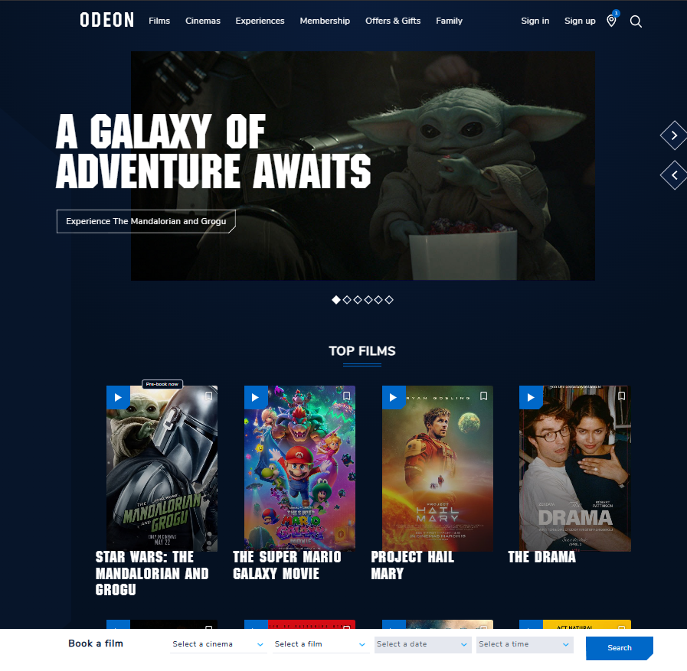
Odeon film listings page (odeon.co.uk)
Similar to Vue, Odeon presents films using large poster images organised under a Top Films heading. However Odeon includes additional information directly on the film page such as the director, cast, runtime, release date and genre tags. This richer level of detail gives customers more context before making a booking decision. Odeon also includes a quick search bar at the bottom of the page allowing users to filter by cinema, film, date and time. One notable difference from Vue is that Odeon uses a darker navy blue colour scheme throughout which creates a more premium feel. For Filmtopia I will aim to display key film information clearly on the customer kiosk so customers can make informed decisions quickly.
Screening Times Page
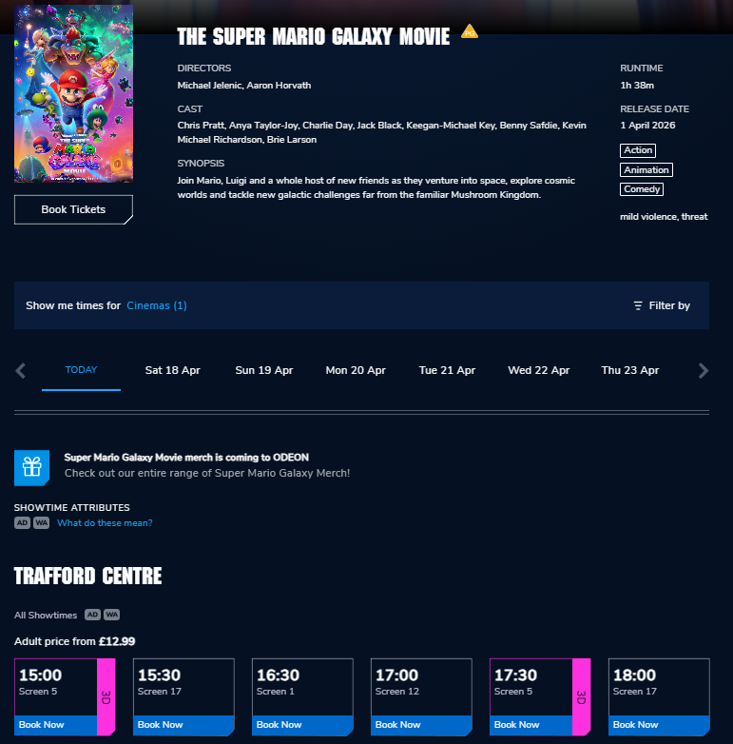
Odeon screening times page (odeon.co.uk)
Odeon's screening times page clearly displays the film title, runtime, release date and genre alongside all available showtimes. Screenings are organised by date across the top of the page and grouped by cinema location below. Each screening card shows the start time, screen number and format such as 3D. A Book Now button is displayed prominently on each card making the next action immediately obvious. This clear layout is something I will replicate in Filmtopia where staff should be able to see all screenings for a given film at a glance.
Seat Selection Screen
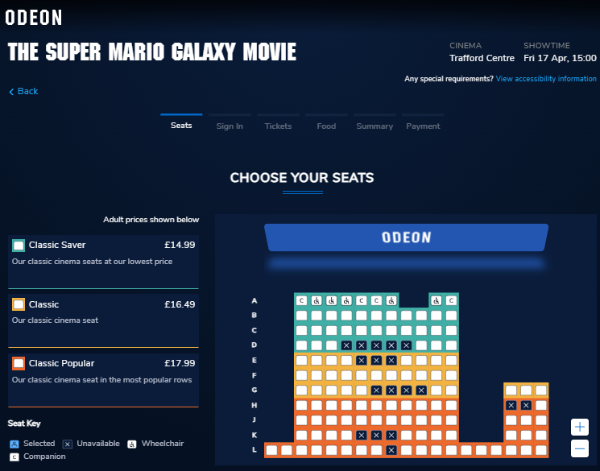
Odeon seat selection screen (odeon.co.uk)
Odeon's seat selection screen is particularly well designed and shows several features worth incorporating into Filmtopia. The screen displays a graphical layout of the entire auditorium with seats colour coded by type and price. Green seats represent Classic Saver at £14.99, cream seats represent Classic at £16.49 and orange seats represent Classic Popular at £17.99. Unavailable seats are shown with an X so it is immediately clear which seats cannot be booked. A seat key at the bottom explains the colour coding including wheelchair and companion seat options. The booking process is also clearly structured using a step by step tab navigation at the top showing Seats, Sign In, Tickets, Food, Summary and Payment. This staged approach guides the user through the process logically and reduces confusion. For Filmtopia I will incorporate a similar colour coded seat map and a clear step by step flow for the customer kiosk booking process.
Features Identified for Filmtopia
- Detailed film information displayed alongside the listing including runtime and genre
- Colour coded seat map with a clear seat key explaining each colour
- Unavailable seats clearly marked so users cannot accidentally select them
- A stepped booking process guiding users through each stage in order
- Prominent call to action buttons making the next step always obvious

Data Flow Diagram
The data flow diagram below shows how data currently moves through the existing system. It identifies the external entities involved, namely the customer, the staff member and the manager, the processes that act on the data, and the data stores where information ends up such as the paper booking diary and the stock and rota spreadsheets. The labelled arrows show the data that passes between them.
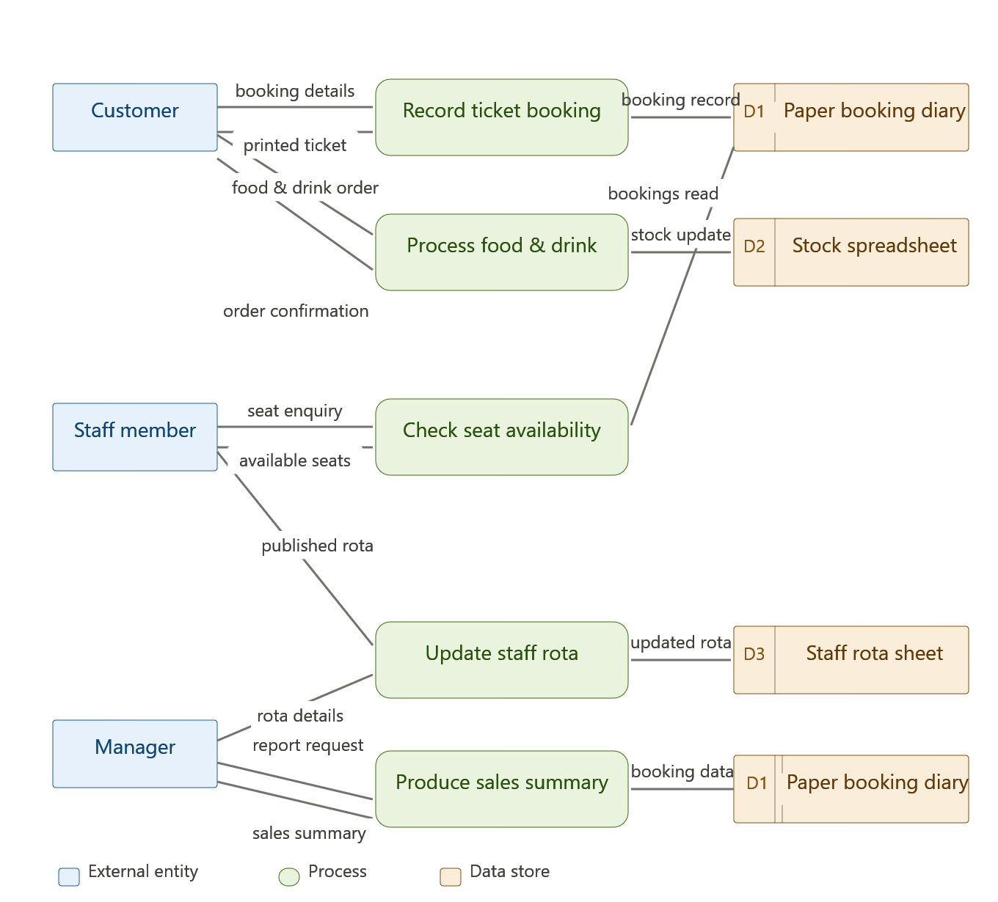
Data flow diagram of the existing system

Overview of the Existing System
Before designing and building a new system it is important to fully understand how the existing one works. This includes looking at what data goes into the system, what comes out of it, how that data is processed in between and where the system falls short. Without this understanding there is a risk of building something that solves the wrong problems or misses important requirements entirely.

Inputs
The existing system at Filmtopia receives several types of input, all of which are entered manually by staff or the manager. When a customer arrives to book tickets a member of staff writes the customer's name, chosen film, screening time, number of tickets and preferred seats into a paper booking diary. There is no digital record of this at the point of entry meaning the accuracy of the data depends entirely on the staff member's handwriting and attention to detail.
When a customer purchases food or drinks at the concessions area their order is written on a notepad by a staff member and passed to the kitchen team. This is a completely separate process from the ticket booking and the two are never linked together in any way. If a customer wants to book tickets and order food at the same time they have to interact with two different systems and two different members of staff.
When a new film is added to the schedule or a screening time changes the manager updates a paper schedule kept at the box office. There is no automated way of notifying staff of changes which means it is possible for staff to be working from outdated information without realising. Stock levels for food and drink are updated on a spreadsheet periodically by the manager, meaning the data is never truly up to date and relies on manual stock counts being carried out regularly.

Processing
The processing that takes place in the existing system is carried out entirely by hand rather than by any software. When a customer asks for a specific seat a staff member must physically look through the paper booking diary to check whether that seat has already been assigned for that screening. This process is slow and becomes increasingly unreliable during busy periods when multiple staff members are taking bookings at the same time. Because there is no central record that updates in real time two members of staff can independently assign the same seat to different customers without either being aware of it until the customers arrive.
When a customer books tickets the total cost is calculated manually by the staff member based on the number of tickets and the price for that screening. There is no automated pricing system meaning human error in the calculation is possible. At the end of a trading period the manager must manually count through all entries in the booking diary and cross reference with till receipts to produce any kind of sales summary. This is a time consuming process that the manager has described as unreliable because it depends on the handwritten records being complete and legible.

Outputs
The outputs from the existing system are limited and almost entirely paper based. When a customer completes a ticket booking a staff member prints a ticket stub from a basic template on a computer and hands it to the customer. This ticket stub is not linked to any database and contains only the information that the staff member manually entered into the template at the time of printing.
At the end of each week the manager produces a handwritten or basic spreadsheet summary of sales figures by counting through the booking diary. This is the only form of reporting available to the manager and it provides no breakdown by film, screening time or seat type. Staff rotas are produced by the manager in a spreadsheet and printed out for staff to view. There is no digital way for staff to check their rota without physically being at the cinema.

Strengths of the Existing System
It would be unfair to look only at what is wrong with the existing system without acknowledging that it does have some genuine strengths, and understanding these matters because the new system needs to hold on to them rather than lose them. The first strength is that it is extremely cheap to run. Paper diaries and spreadsheets cost almost nothing and there are no licensing fees or special hardware requirements beyond the computer the cinema already owns. The second strength is that the staff are completely familiar with it. Because there is nothing technical about writing in a diary, a new member of staff can be shown how it works in a couple of minutes and there is no real training overhead at all. The third strength is that it keeps working when technology does not. A paper system cannot crash, it does not depend on a database connection and it carries on functioning during a power cut or a computer fault.
These are real advantages and they set a standard the proposed system has to meet rather than ignore. The new system needs to run on the existing hardware so it stays cheap, it needs to be easy enough to use that staff need almost no training, and it needs to be reliable enough that staff trust it as much as they currently trust the diary. This is part of the reason Objectives 14 and 15, which deal with a consistent professional interface and easy navigation, are included later in this investigation.

Limitations
The existing system has several significant limitations that have been clearly identified through the investigation. The most serious of these is the risk of double bookings. Because there is no centralised real time record of seat allocations the same seat can be assigned to two different customers for the same screening. This has happened on multiple occasions and has resulted in customers arriving to find their seat already occupied. Not only is this a poor experience for the customer but it reflects badly on the cinema and undermines trust in the booking process.
Another significant limitation is the complete lack of meaningful reporting. The manager currently has no way of knowing how many tickets have been sold for a particular film, which screenings are most popular or what the cinema's total revenue is for a given period without manually processing a large amount of paper records. This makes it very difficult to make informed business decisions.
The customer facing experience is also heavily limited by the current setup. The touchscreen kiosk that is already installed in the cinema can handle food and drink orders but cannot sell tickets. This forces customers to queue at both the kiosk and the box office which is inefficient and frustrating. Several customers raised this issue in the questionnaire and it was also clearly visible during the observation visit.
Finally the data in the existing system is spread across multiple completely disconnected sources including the paper booking diary, a food and drink stock spreadsheet and a staff rota spreadsheet. None of these communicate with each other which makes it impossible to get a complete and accurate picture of the cinema's operations in one place. This disconnection is at the root of many of the other problems identified in the investigation.

Problem Definition
Having completed the investigation through interviews, a customer questionnaire, direct observation, an examination of the cinema's records and desk based research, it is now possible to clearly define the problem that the proposed solution needs to address. The purpose of this section is to bring together the key findings from the investigation and explain precisely what needs to change and why, and to point to the objectives in the next section that will deal with each part of the problem.
Filmtopia is a small independent cinema that is currently managing all of its operations using a combination of paper records and disconnected spreadsheets. This approach may have been adequate when the cinema first opened but it has become increasingly problematic as the demands on the system have grown. The core problem is that the existing system is unreliable, slow and disconnected, and this is having a direct negative impact on both staff and customers.
The most critical issue identified through the investigation is the risk of double bookings. Because seat allocations are recorded manually in a paper diary with no real time updating, two members of staff can independently assign the same seat to different customers for the same screening without either being aware of it. This was confirmed by both members of staff interviewed and by 65% of customers in the questionnaire who reported having experienced a problem when booking at Filmtopia. It was also directly observed during the site visit. This is not an occasional or minor issue but a fundamental flaw in how the existing system manages booking data. A relational database with referential integrity enforced between the relevant tables will directly address this by ensuring that once a seat is recorded as booked for a particular screening it cannot be booked again. This is dealt with by Objective 2 in the next section and supported by Objective 3, which covers the graphical seat map that makes taken seats visible at a glance.
The second major problem is the disconnected nature of the existing system. Ticketing, food and drink ordering, stock management and staff scheduling are all handled through separate paper or spreadsheet based systems that do not communicate with each other in any way. This means the manager has no way of viewing a complete picture of the cinema's operations without manually compiling data from multiple sources which is both time consuming and prone to error. A centralised relational database will resolve this by storing all of the cinema's operational data in one place with clearly defined relationships between tables, making it possible to retrieve and cross reference data quickly and accurately. This is dealt with by Objectives 6 and 7, which cover film and screening management, and by Objectives 8 and 9, which cover sales reporting and viewing the bookings for a screening.
The third significant problem is the poor customer facing experience. The kiosk currently installed in the cinema can only handle food and drink orders and cannot sell tickets, which forces customers to queue at both the kiosk and the box office. This was raised by multiple customers in the questionnaire and observed directly during the site visit. The proposed solution will address this by providing a customer kiosk interface through which customers can browse films, select a screening, choose their seats and add food and drink items to their order in a single joined up process. This is dealt with by Objective 4, which covers the self service kiosk, and Objective 5, which covers adding food and drink to a booking.

Requirements Analysis
To ensure the proposed solution fully addresses the problems identified above it is helpful to break the requirements down into two categories: functional requirements and non-functional requirements.
Functional requirements are the specific things the system must be able to do. For Filmtopia these include the ability to add and manage films and screenings (Objectives 6 and 7), to display a graphical seat map showing which seats are available and which are already booked (Objective 3), to process customer bookings and link them to specific seats and screenings (Objectives 1 and 2), to allow food and drink orders to be added to a booking (Objective 5) and to generate sales reports for the manager (Objective 8). These requirements map directly to the objectives set out later in this investigation.
Non-functional requirements are the qualities the system must have rather than the specific things it must do. For Filmtopia the most important non-functional requirements are reliability, usability and data integrity. The system must be reliable enough to be used continuously during opening hours without crashing or producing errors. It must be usable by staff with varying levels of technical confidence without extensive training, which is reflected in Objectives 14 and 15. And it must maintain data integrity at all times, meaning it should never be possible for the database to reach a state where bookings are duplicated, records are incomplete or data is inconsistent between tables, which is reflected in Objectives 2 and 13.

Proposed Solution
The proposed solution is a Visual Basic .NET Windows Forms application built in Visual Studio, using OleDb to manage the connection between the application and a Microsoft Access database stored in the Access 2002 to 2003 .mdb format. Visual Basic .NET has been chosen because it is the language used throughout this course and it allows the rapid development of graphical Windows applications with a professional user interface. OleDb has been chosen as the database connectivity method because it provides a straightforward and reliable way of connecting a Visual Basic .NET application to a Microsoft Access database, allowing SQL queries to be executed directly from the application code to insert, update, delete and retrieve records. Microsoft Access has been chosen as the database because it supports a full relational structure with primary keys, foreign keys and referential integrity which directly addresses the data management problems identified in the investigation.
The system will support three distinct user types each with their own interface and access level. Customers will access the system through a self service kiosk interface. Staff will be able to log in to manage bookings and screenings. The manager will have full access to all areas of the system including film management and sales reporting. Access levels will be enforced through the login system to ensure that users can only access the parts of the system that are relevant to their role, which is dealt with by Objective 10.

Limitations of Proposed Solution
Whilst the proposed Filmtopia system will address the core problems identified in the investigation, there are several areas that will not be included in the solution due to constraints of time, scope and available hardware and software. These limitations are outlined below.
The system will not include online booking functionality. Developing a web based booking system that allows customers to purchase tickets remotely would require a web server, a publicly accessible database and a payment processing integration, all of which are beyond the scope of an A Level project. The system will instead focus on in-cinema operations at the box office and customer kiosk.
The system will not include a real payment processing system. Taking card or cash payments involves integration with chip and pin hardware and payment gateway APIs which are not available for this project. Payment will be simulated within the system and the process of actually collecting money from the customer will be assumed to happen separately.
The system will not include a mobile application. Developing iOS or Android applications would require additional software, hardware and significant development time beyond what is available for this project.
The system will not support multiple simultaneous users over a network. Whilst OleDb connections to a Microsoft Access database can technically support multiple users, developing a fully networked multi-user system with appropriate concurrency controls and conflict resolution is beyond the scope of this project. The system will be designed for use on a single machine or a small number of machines accessing the same .mdb database file locally.
The system will not include automated staff scheduling or payroll functionality. Managing staff rotas and wages involves complex business logic and legal considerations that are outside the scope of this project. Staff management features will be limited to basic record keeping.
The system will not send automated notifications or emails to customers. Whilst it would be useful to send booking confirmation emails or screening reminders, this would require email server integration and SMTP configuration which is not available within the Visual Studio development environment used for this project.
The system may track stock at item level, reducing quantities automatically as items are sold and allowing the manager to adjust counts manually, but it will not handle supplier ordering, deliveries or full stock reconciliation as these fall outside the scope of this project.

Objectives and Evaluation Criteria
The following objectives have been produced based on the findings of the investigation. Each objective is numbered and includes a success criteria which will be used to evaluate whether the objective has been met when the project is complete.
Objective 1(P): The system must allow staff to add new customer ticket bookings for a selected screening, recording the customer name, chosen seats and number of tickets.
Success Criteria: A new booking should be added to the Microsoft Access database in under 30 seconds. The booking record should appear immediately in the database with the correct customer name, screening, seat numbers and ticket quantity. Validation should prevent a booking being saved without all required fields completed.
Objective 2 (P): The system must prevent double bookings by ensuring that a seat which has already been allocated to a customer cannot be selected by another customer for the same screening.
Success Criteria: When a seat is already booked for a screening it should be visually marked as unavailable on the seat selection interface and it should be impossible to select or book it. Attempting to book an already taken seat should display a clear error message.
Objective 3 (P): The system must display a graphical seat map for each screening showing which seats are available and which are already booked.
Success Criteria: The seat map should load within 3 seconds of a screening being selected. Available seats and booked seats should be displayed in clearly distinguishable colours. The seat map should accurately reflect the current state of the database at the time of loading.
Objective 4: The system must allow customers to purchase tickets through a self-service kiosk interface, selecting a film, screening time, seats and completing their booking without staff assistance.
Success Criteria: A customer should be able to complete a full ticket booking through the kiosk interface in under 2 minutes. The kiosk should guide the customer through each stage clearly using buttons and on screen instructions. The completed booking should be recorded in the database correctly.
Objective 5 (P): The system must allow customers to add food and drink items to their order at the same time as booking tickets, with the combined order saved to the database.
Success Criteria: Food and drink items should be displayed on a clearly navigable menu during the booking process. A customer should be able to add multiple items to their order. The food and drink order should be saved to the database linked to the correct booking record.
Objective 6 (P): The system must allow staff and managers to add new films to the system, including the film title, age rating, duration and description.
Success Criteria: A new film record should be saved to the database in under 20 seconds with all required fields validated. The film should immediately appear in the list of available films when adding a new screening. Duplicate film titles should be prevented through validation.
Objective 7 (P): The system must allow staff and managers to add new screenings for existing films, specifying the screen, date, time and ticket price.
Success Criteria: A new screening record should be saved to the database correctly linked to the selected film. The screening should immediately appear in the list of available screenings on the customer kiosk. Validation should prevent a screening being added without a valid date, time, screen and ticket price.
Objective 8 (P): The system must allow the manager to view a sales report showing total ticket sales and revenue for a selected date range.
Success Criteria: The report should be generated using an SQL query through the OleDb connection and displayed on screen within 5 seconds of the date range being selected. The report should show the correct total number of tickets sold and total revenue for the selected period, calculated directly from the bookings in the database.
Objective 9 (P): The system must allow the manager to view a list of all bookings for a selected screening, showing customer names, seat numbers and the number of tickets booked.
Success Criteria: The booking list should load within 3 seconds of a screening being selected. All bookings for that screening should be displayed accurately. The list should be printable or exportable for use as a physical register.
Objective 10 (P): The system must enforce access levels so that customers using the kiosk can only access booking functions, whilst staff can access management functions and managers can access all areas of the system. (*Note: the kiosk is strictly post-prototype material. However, access levels need to be enforced from the prototype.)
Success Criteria: The kiosk interface should not display any staff or manager options. Staff should be able to log in with a username and password and access staff functions only. The manager login should provide access to all areas of the system. Attempting to access a restricted area without the correct login should be prevented.
Objective 11 (P): The system must allow staff to search for an existing booking by customer name or booking reference.
Success Criteria: A search by customer surname should return all matching bookings within 2 seconds. The search should work with partial name entries. The correct booking record should be displayed with all associated details including film, screening, seats and food order.
Objective 12 (P): The system must allow staff to cancel an existing booking, removing the seat allocation from the database and making those seats available again.
Success Criteria: Cancelling a booking should update the database immediately so the seats become available for other customers. A confirmation prompt should be displayed before any booking is deleted. The cancelled booking should no longer appear in the active bookings list.
Objective 13 (P): The system must validate data entered by users to prevent invalid or incomplete records being saved to the database.
Success Criteria: All required fields should be validated before a record is saved. Numeric fields should only accept numbers. Date fields should only accept valid dates. Text fields should have appropriate maximum lengths enforced. An informative error message should be displayed for each validation failure explaining what needs to be corrected.
Objective 14: The system must have a consistent and professional user interface across all forms, using a uniform colour scheme, layout and naming convention throughout.
Success Criteria: All forms should use the same colour scheme, font and button placement. Navigation buttons should appear in consistent positions across all forms. The system should look professional and be immediately recognisable as a Filmtopia branded application.
Objective 15: The system must be easy to navigate, with clearly labelled menus and buttons that allow staff and customers to find the function they need without requiring technical knowledge.
Success Criteria: A new member of staff should be able to complete a basic booking using the system without any training beyond a brief introduction. All buttons and menu options should use clear plain English labels. The system should never reach a state where the user cannot navigate back to the main menu.
Objective 16 (P): The system must allow a manager to create a new screen by entering a total number of seats, with the system automatically generating the corresponding seat map and seat records for that screen.
Success Criteria: Entering a seat count when creating a screen should generate the correct number of seat records in the database, arranged into rows and columns for a usable seat map. The generated seat map should display correctly when a screening for that screen is selected. Creating a screen with an invalid or missing seat count should be prevented through validation.
Objective 17 (P): The system must maintain an audit log recording key actions carried out by staff and managers, including creating a booking, cancelling a booking and adding a new film or screening record.
Success Criteria: Every booking created, cancelled or amended should generate a log entry showing the username of the staff member responsible along with the date and time of the action. The audit log should be viewable by the manager but should not be editable or deletable by staff. The log should accurately reflect every relevant action carried out in the system during normal operation.
Objective 18: The system must allow staff to process a refund for a cancelled booking, recording the refunded amount against the original booking record.
Success Criteria: A refund should only be processable for a booking that has already been cancelled. The refunded amount should be calculated automatically from the ticket price and any food and drink items originally recorded against the booking. The refund should be saved to the database with a timestamp and should be visible when the booking is looked up afterwards.

Filmtopia Project Section 3: Design

Inputs, Outputs and User Interface Design
The purpose of this section is to design the way that the user will interact with the Filmtopia system before any of it is actually built. In other words this is where I plan out every form the user will see, the information that goes into each one and the information that comes back out, so that when I move on to writing the code I already have a clear picture of what I am building rather than making it up as I go along. I have taken each objective in turn as a heading and described how the interface will behave for that objective, and for every form or report involved I have drawn a wireframe showing roughly where the labels, text boxes and buttons will sit. These drawings are deliberately kept simple so that it is obvious they are design sketches and not screenshots of a finished program.
Before going through the objectives one at a time it is worth explaining a couple of decisions that apply across the whole system. Filmtopia is built as a Windows Forms desktop application, so every screen is a form made up of standard controls such as text boxes, labels, buttons and data grids. I have chosen to name my controls using a short prefix that describes what each one is, for example txt for a text box, btn for a button, lbl for a label, cbo for a combo box and dgv for a data grid view, followed by a word describing its job. This is because a consistent naming convention makes the code far easier to read later on and stops me getting confused between similarly named items. I have also decided not to worry too much about the finer details of colour at this stage, this is because the guidance makes clear that the interface will be refined after the prototype in section 5.2, so it makes sense to settle the layout and the flow first and then tidy up the appearance once I know everything works.

User Login and Access Levels (Objective 10)
The first thing any user meets when they open Filmtopia is the login screen, so this is where the design naturally starts. The objective here is to make sure that customers, staff and managers are not all able to do the same things, because a normal member of staff being able to reach the manager's sales reports or the audit log would be a serious security weakness. To achieve this the system asks for a username and a password on a small login form, checks them against the tblLogin table, and reads back an access level number that then decides what the user is allowed to see.
The login form itself is deliberately kept small and uncomplicated. It has a header panel across the top showing the name Filmtopia and the subtitle Cinema Management System so the user knows straight away what they are logging into. Below that are two labels, Username and Password, each sitting next to its own text box, which I have named txtUsername and txtPassword. The password box will have its characters masked so that anyone standing nearby cannot read what is being typed. Underneath the boxes are two buttons, a Log In button named btnLogin which carries out the check, and a Cancel button named btnClose which closes the program if the user changes their mind. A small version label sits at the very bottom of the form.
Login Form (frmLogin)
Filmtopia
Username
Password
Log In

Cancel

Filmtopia Management System v1.0.2
The only input to this form is the username and password typed by the user. The output, once the button is pressed, is either entry into the main menu or a message box telling the user that their details were not recognised. The process that happens in between is a lookup against the tblLogin table for a matching username, a comparison of the stored password, and if everything matches, the storing of that user's access level in a variable called UserAccessLevel that the rest of the program can read. I have chosen buttons here rather than, for example, expecting the user to press the Enter key, this is because a clearly labelled Log In button leaves no doubt about what to do and is friendlier for staff who are not especially technical.
Once a user has logged in successfully they are taken to the main menu, which is the form named frmMainForm and acts as the hub for the whole system. Every other part of Filmtopia is reached from here by pressing a button, which I felt was a far more sophisticated and easier to follow approach than burying features inside drop-down menus that a busy member of staff would have to go hunting through. The menu shows a welcome message at the top and then a column of buttons down the content area, one for each area of the system, for example Bookings, Find Booking, Screenings, Films, Screens, Food, Reports, Customers, Logs and a Logout button.
What makes this form important for the objective is that the buttons shown depend entirely on the access level that was read at login. This is because a manager, whose access level is 1, needs to see everything, whereas a normal member of staff, whose access level is 2, should only see the day to day booking functions. When a manager logs in the group box is titled Filmtopia Admin and the management buttons for Films, Screens, Food, Reports and Logs are all made visible. When a member of staff logs in those same buttons are hidden and the group box is titled Filmtopia Staff, leaving them with just the booking related functions. In this way a single form quietly enforces the whole access level objective without the staff member ever seeing an option they are not allowed to use.
Main Menu (frmMainForm)
Filmtopia Manager
Bookings
Find Booking
Screenings
Customers
Films
Screens
Food
Reports
Logs
Settings
-Log out
Use the buttons on the left to get around the system:

- Bookings: make and manage customer bookings
- Find Booking: search for a booking and cancel it
- Screenings: see what films are showing and when
- Customers: look up customer details
- Films: add and edit films (managers only)
- Screens: set up screens and seating (managers only)
- Food: manage food and drink items (managers only)
- Reports: view sales reports (managers only)
- Logs: view a history of actions taken in the system (managers only)

Use the Log out button at the bottom when you are finished.

Welcome!
The input to the main menu is simply the button the user chooses to press. The output is the opening of whichever form that button is linked to. There is no data entry on this screen at all, this is because its only job is navigation, and keeping it free of clutter makes it obvious where everything lives.

Adding New Films (Objective 6)
Moving on to the management side of the system, one of the first jobs a manager or member of staff needs to do is add the films that the cinema is showing, because without any films in the system there is nothing for a screening to be attached to. This objective is handled by a single form named frmFilms which lets the user add a new film, edit an existing one, or remove one that is no longer being shown.
The form is split into two halves. On one side is a data grid view named dgvFilms which lists every film already stored in the system, showing its title, age rating, duration and description in a table so the user can see at a glance what is already there. On the other side is a set of input boxes for the details of a film, made up of a label and a text box for each field, which I have named txtTitle, txtAgeRating, txtDuration and txtDescription. Beneath these are four buttons, Add, Update, Delete and Clear, which I have named btnAdd, btnUpdate, btnDelete and btnClear.
Add Films Form (frmFilms)
FilmID
FilmTitle
FilmAgeRating
FilmDuration
FilmDescription
►
1
Inception
12A
148
A thief who steals corporate secrets through dream-sharing technology.
2
The Dark Knight
12A
152
Batman fights the Joker in Gotham City.
3
Interstellar
PG
169
A team of explorers travel through a wormhole in space.
4
The Amazing Spider-Man
PG
136
After Peter Parker is bitten by a genetically altered spider, he gains newfound, spider-like powers and ventures out to save the city from the machinations of a mysterious reptilian foe.
5
Spider-Man: Across the Spider-Verse
PG
140
Travelling across the multiverse, Miles Morales meets a new team of Spider-People, made up of heroes from different dimensions. But when the heroes clas over how to deal with a new threat, Miles finds himself at a crossroads.
Title
Age Rating
Duration (mins)
Description
Add
Update
Delete
Clear
Filmtopia Cinema Management System v1.0.2
The inputs to this form are the four film details typed into the text boxes. The outputs are the updated list of films shown in the grid and, where appropriate, a message box confirming that a film has been added or warning the user if something has gone wrong. The processes behind the buttons are straightforward database operations, for example the Add button takes whatever is in the text boxes and inserts a new record into the tblFilm table, whereas the Update button changes the record for the film currently selected in the grid, and the Delete button removes it. The Clear button simply empties the text boxes so the user can start again.
I have laid the form out with the list on one side and the editing boxes on the other, this is because it lets the user see the existing data and the thing they are editing at the same time rather than flipping between two separate screens. I have again used clearly labelled buttons for each action, this is because it makes it obvious what each one does and avoids the user accidentally deleting a film when they only meant to update it. This same pattern, a list on one side and input boxes with Add, Update, Delete and Clear buttons on the other, is reused across several of the management forms, so where a later objective uses the same layout I will refer back to this description rather than repeating it.

Adding New Screenings (Objective 7)
Once films exist in the system the next job is to schedule when and where they will actually be shown, which is what this objective covers. It is handled by the form named frmScreenings, and because it is another management form for adding, editing and removing records it follows exactly the same layout as the Add Films form described above, with a data grid view named dgvScreenings listing the existing screenings on one side and a set of input controls with Add, Update, Delete and Clear buttons on the other. Rather than repeat the whole description I will refer back to the Add Films form for the general behaviour and just explain what is different here.
The difference is in the inputs. A screening has to be tied to a film that already exists and a screen that already exists, so instead of free text boxes for those two the form uses two combo boxes, named cboFilm and cboScreen, which the user picks from. This is because a member of staff should not be able to type in a film or a screen that is not really there, and choosing from a list makes that impossible. The date is entered using a date picker named dtpScreeningDate rather than a text box, this is because a proper date picker stops the user entering something that is not a real date. The time and the ticket price are entered into text boxes named txtScreeningTime, which is labelled Time in the format HH colon MM, and txtTicketPrice.
Add Screenings Form (frmScreenings)
ScreeningID
FilmTitle
ScreenName
ScreeningDate
ScreeningTime
TicketPrice
►
1
Inception
Screen 1
20/04/2026
14:00
9.99
2
Inception
Screen 2
20/04/2026
17:30
9.99
3
The Dark Knight
Screen 1
21/04/2026
19:00
11.99
7
The Amazing Spider-Man
Screen 4
15/06/2026
10:10
6.99
8
Spider-Man: Across the Spider-Verse
Screen 3
15/06/2026
12:00
7.99
9
Interstellar
Test Screen 2
15/06/2026
14:00
7.99
Film
Screen
Date
21/07/2026
Time (HH:MM)
Ticket Price
Add
Update
Delete
Clear
Filmtopia Cinema Management System v1.0.2
The inputs are therefore the chosen film, the chosen screen, the date, the time and the ticket price. The output is the updated list of screenings in the grid, along with the usual confirmation or warning message boxes. The processes behind the buttons are the same insert, update and delete operations as before, this time acting on the tblScreening table.

Creating a Screen with Automatic Seat Generation (Objective 16)
Before a screening can be booked the cinema needs its physical screens set up in the system, each with the right number of seats. This objective is handled by the form named frmScreens, which once again uses the same familiar management layout with a data grid view named dgvScreens listing the existing screens and a small set of inputs with Add, Update, Delete and Clear buttons, so I will refer back to the Add Films form for that general behaviour. There are only two inputs here, a text box named txtName for the name of the screen and a text box named txtCapacity for how many seats it has.
The interesting part of this objective, and the reason it is worth documenting separately, is what happens behind the Add button. When the user enters a name and a capacity and presses Add, the system does not just save the screen, it then automatically generates that number of seat records for it. In other words if the manager types a capacity of sixty, the system creates sixty individual seats for that screen without the manager having to type a single one of them in by hand. This was a direct response to feedback during the discussion stage, where it was pointed out that setting up every seat manually would be a nightmare, so having the system do it automatically is far more sophisticated and removes any chance of human error. If a screen is later edited and its capacity changes, the old seats are cleared out and a fresh set is generated to match, and if a screen is deleted its seats are removed first.
Add Screens Form (frmScreens)
ScreenID
ScreenName
ScreenCapacity
►
1
Screen 1
60
2
Screen 2
60
3
Screen 3
60
4
Screen 4
90
5
Screen Test
20
6
Test Screen 2
120
7
Screen 6
10
Name
Capacity
Add
Update
Delete
Clear
Filmtopia Cinema Management System v1.0.2
The inputs are the screen name and the capacity. The outputs are the updated list of screens and, crucially, a full set of seat records created in the tblSeat table for the new screen. The process behind the Add button is therefore two steps, first inserting the screen into the tblScreen table and reading back the new screen's identifier, and then looping to insert one seat record per seat into the tblSeat table so that the seats are ready for the booking form to use.

Adding Customer Bookings and Preventing Double Bookings (Objectives 1 and 2)
This is the heart of the whole system and the reason the project exists in the first place, so it is the most involved form to design. The objective is to let a member of staff create a booking for a customer against a particular screening, recording who the customer is, which seats they want and how many tickets that comes to, while making it impossible for a seat that has already been booked to be sold twice. Both of these objectives are handled together on the one form named frmBookings, because in practice they are the same job.
The top of the form has two combo boxes, named cboScreening and cboCustomer, where the member of staff first picks which screening the booking is for and then which customer it belongs to. There is also a check box named chkWalkIn labelled Walk-in, which lets staff take a booking for a customer who has just walked in without recording their details. The largest part of the form is a panel named pnlSeatMap which draws the seat map for the chosen screening, and next to it is a small legend made up of three coloured swatches labelled Available, Selected and Taken so the user knows what the colours mean. A label named lblTotal keeps a running count of how many seats have been selected, and along the bottom are the action buttons, Create Booking named btnCreateBooking, Clear Selection named btnClear, Order Food named btnOrderFood and Sell Food Only named btnFoodOnly. A grid named dgvCustomerBookings shows the bookings the selected customer already has.
Bookings Form (frmBookings)
Screening
The Dark Knight - 21/04/2026 19:00
Customer
Kevin Hart
Walk-in (no details)
-------------------------------- SCREEN --------------------------------
A1
A2
A3
A4
A5
A6
A7
A8
A9
A10
B1
B2
B3
B4
B5
B6
B7
B8
B9
B10
C1
C2
C3
C4
C5
C6
C7
C8
C9
C10
D1
D2
D3
D4
D5
D6
D7
D8
D9
D10
E1
E2
E3
E4
E5
E6
E7
E8
E9
E10
F1
F2
F3
F4
F5
F6
F7
F8
F9
F10
Available
Selected
Taken
0 seats selected - £0.00
Create Booking
Clear Selection
Sell Food Only (No Seat)
Order Food
Customer's Bookings
Booking
Info
34
The Dark Knight (21/04/2026)
Filmtopia Cinema Management System v1.0.2
The way the member of staff uses the form is that they choose a screening, choose a customer or tick the walk-in box, and the seat map then draws itself as a grid of clickable seat buttons laid out like the inside of the screen. Clicking an available seat selects it and it changes colour, and the running total updates as they go. When they are happy they press Create Booking. The inputs to the form are therefore the chosen screening, the chosen customer and the seats that are clicked. The outputs are the saved booking, a confirmation message, the refreshed seat map and the updated list of that customer's bookings. The processes behind the scenes are the insertion of a new record into the tblBooking table and the insertion of each chosen seat into the tblBookingSeat table.
Preventing double bookings, which is the whole point of Objective 2, is built directly into how the seat map is drawn. This is because when the map loads it asks the database which seats have already been booked for that screening, by looking in the tblBookingSeat table joined to the tblBooking table, and any seat that comes back as already taken is coloured with the Taken colour and, more importantly, is disabled so that it physically cannot be clicked. On top of that, as a second line of defence, when Create Booking is pressed the system checks once more that none of the selected seats have been taken by someone else in the meantime before it saves anything. In this way a seat can never be sold twice, both because a taken seat cannot be selected in the first place and because it is checked again at the moment of saving. I chose a clickable graphical seat map rather than, for example, asking staff to type in seat numbers, this is because it lets them see the whole screen at a glance and makes double booking obvious and impossible in a way that a list of numbers never could.

Displaying the Graphical Seat Map (Objective 3)
This objective is really a closer look at the seat map that has just been described on the booking form, so rather than design a separate screen for it I will refer back to the frmBookings form above. The seat map is the panel named pnlSeatMap, and its job is to show, for a chosen screening, exactly which seats are free and which are already booked. It does this by drawing one button for every seat in the chosen screen, arranged in rows so that it looks like the layout of a real cinema, with a label above reading SCREEN so the user can tell which way round they are looking.
Every seat button is shown in one of three colours, and this is the output the user cares about. An available seat is shown in the Available colour and can be clicked, a seat the user has just clicked is shown in the Selected colour, and a seat that has already been booked by someone else is shown in the Taken colour and cannot be clicked at all. The small legend of coloured swatches next to the map explains which colour means what. The only input to the seat map is the clicks the user makes on the available seats, and behind the scenes the colours are worked out by comparing the full list of seats for the screen against the list of seats already booked for that screening. I have kept the fine detail of the exact colours to be settled in section 5.2, but the important design decision here is the three state system of available, selected and taken, because it is what makes the availability instantly readable.

Adding Food and Drink to an Order (Objective 5)
One of the main aims of Filmtopia was that a customer should be able to add food and drink onto their ticket booking in the same visit, so that it feels like one joined-up transaction rather than two separate ones. This objective is handled by the form named frmFoodOrder, which is opened straight from the booking form by pressing the Order Food button once a booking has been made, or by pressing Sell Food Only if the customer only wants snacks and no seat. Opening it directly from the booking is a deliberate design choice, this is because it keeps the whole thing as a single flowing process for the member of staff.
At the top of the form a label named lblBookingInfo shows which booking the food is being added to, so there is no confusion about whose order it is. Below that is a combo box named cboFoodItem where the user picks a food or drink item from the list the cinema sells, a label named lblPrice which shows the price of the chosen item, and a text box named txtQuantity for how many they want, which sensibly defaults to one. A grid named dgvOrderItems builds up the list of items that have been added to the order, and a label named lblTotal keeps a running total of the cost. The buttons are Add To Order named btnAddItem, Remove Selected named btnRemoveItem, and Close named btnClose.
Food Order Form (frmFoodOrder)
Booking #34 - Kevin Hart - The Dark Knight (21/04/2026 00:00:00 19:00)
Food Item
Coca Cola
£2.99
Quantity
1
Add To Order
FoodItemName
FoodItemPrice
Quantity
Subtotal
Large Popcorn
4.99
4
19.96
Remove Selected
Total: £19.96
Close
Filmtopia Cinema Management System v1.0.2
The inputs to this form are the food item chosen and the quantity. The outputs are the growing list of items in the grid, the updated running total, and the items being saved against the booking. The process behind the Add To Order button is to insert the chosen item and quantity into the tblOrderItem table linked to the booking, and then to recalculate and display the new total. I chose a combo box for the items rather than a text box because the food menu is a fixed list, so picking from it is both faster and stops the user entering something the cinema does not sell, and defaulting the quantity to one saves the most common case of a single item being typed every time.

Searching for a Booking (Objective 11)
Staff often need to find a booking again after it has been made, for example if a customer rings up about it, so this objective provides a way to search for one. It is handled by the form named frmBookingSearch, which is reached from the Find Booking button on the main menu. This same form also handles cancelling a booking and viewing the screening register, which are the next two objectives, because they all naturally belong together in one place. For the search itself the form has a text box named txtSearch, labelled Booking ID or Customer Name, a Search button named btnSearch, a Show All button named btnShowAll, and a grid named dgvBookings where the results appear.
Booking Search Form (frmBookingSearch)
Booking ID or Customer Name
Search
Show All
BookingID
CustomerName
FilmTitle
ScreeningDate
ScreeningTime
TotalCost
►
2
Jane Doe
The Dark Knight
21/04/2026
19:00
£11.99
16
John Smith
The Dark Knight
21/04/2026
19:00
£131.89
17
Loui Polat
The Dark Knight
21/04/2026
19:00
£23.98
23
John Smith
Inception
20/04/2026
14:00
£39.96
24
Jane Doe
The Dark Knight
21/04/2026
19:00
£35.97
26
Walk-in Customer
The Dark Knight
21/04/2026
19:00
£35.97
27
Walk-in Customer
Inception
20/04/2026
17:30
£29.97
28
Walk-in Customer
Inception
20/04/2026
17:30
£29.97
33
Walk-in Customer
Spider-Man: Across the Spider-Verse
15/06/2026
12:00
£7.99
34
Kevin Hart
The Dark Knight
21/04/2026
19:00
£35.97
Cancel Booking
Screening Register
Screening
Load Register
Export CSV
Filmtopia Cinema Management System v1.0.2
The way it works is that the member of staff types either a booking reference or the customer's name into the search box and presses Search, and any matching bookings appear in the grid. If they would rather just see everything, the Show All button lists every booking in the system. The input is therefore the text typed into the search box, the output is the list of matching bookings, and the process behind it is a query against the tblBooking table, joined to the customer details, that looks for a booking whose identifier matches the number typed or whose customer name contains the text typed. I chose to have a single search box that accepts either a booking reference or a name, this is because staff will sometimes have the reference to hand and sometimes only the customer's name, so accepting both keeps it flexible, and the Show All button gives them a simple fallback when they are not sure what to search for.

Cancelling a Booking (Objective 12)
Cancelling a booking is done on the same frmBookingSearch form that was just described, so I will refer back to it rather than design a new screen. Once a member of staff has found the booking they want using the search, they select it in the results grid and press the Cancel Booking button named btnCancelBooking. The input is simply the booking that is selected, and there is no new information to type in. The output is the booking being removed and a confirmation that it has been cancelled.
The important part of this objective is what the process does behind the scenes, because cancelling a booking is not just about deleting it, it also has to free up the seats it was using. This is because if the seats were not released then those seats would stay marked as taken forever and could never be sold again, which would be detrimental to the cinema. So when a booking is cancelled the system first removes that booking's seats from the tblBookingSeat table, which immediately makes them available again on the seat map, and then removes the booking itself from the tblBooking table. In this way the cancelled seats go straight back to showing as available the next time that screening's seat map is opened.

Viewing the Booking Register (Objective 9)
The last job handled by the frmBookingSearch form is letting the manager or staff see a register of every booking for a particular screening, so that they can see who is coming and how full the screening is. I will refer back to that form for the overall layout and just describe the register part here. This part of the form has a combo box named cboRegisterScreening where the user picks the screening they are interested in, a Load Register button named btnLoadRegister, a grid named dgvRegister where the register appears, and an Export CSV button named btnExportRegister.
The way it is used is that the user picks a screening and presses Load Register, and the grid then fills with every booking for that screening, showing the customer names, the seats they have booked and the number of tickets. The input is the chosen screening, and the output is the full register shown in the grid. There is also the option to press Export CSV, which takes whatever is currently shown in the register and writes it out to a comma separated values file that can be opened in a spreadsheet, which is useful if the manager wants to print it or keep a copy. The process behind loading the register is a query that pulls back all of the bookings for the chosen screening, and the export process simply writes those same rows out to a file line by line.

Viewing a Sales Report (Objective 8)
This objective gives the manager an overview of how the cinema is performing, and because it is a management function it is only available when a manager is logged in. It is handled by the form named frmSalesReport, reached from the Reports button on the main menu. The form is kept deliberately simple, with two date pickers named dtpFrom and dtpTo where the manager chooses the start and end of the period they want to look at, a Run Report button named btnRunReport, a grid named dgvSalesByFilm which breaks the sales down film by film, and three summary labels named lblTicketRevenue, lblFoodRevenue and lblGrandTotal.
Sales Report Form (frmSalesReport)
From
15/12/2025
To
21/07/2026
Run Report
FilmTitle
Bookings
TicketRevenue
►
Inception
3
£99.90
Spider-Man: Across the Spider-Verse
1
£7.99
The Dark Knight
6
£275.77
Ticket revenue: £383.66
Food revenue: £60.81
Grand total: £444.47
Filmtopia Cinema Management System v1.0.2
The manager uses it by choosing a from date and a to date and pressing Run Report, at which point the grid fills with the sales for each film over that period and the three labels update to show the total ticket revenue, the total food revenue and the grand total of the two added together. The inputs are the two dates, and the outputs are the breakdown by film in the grid together with the three revenue totals. The process behind the button is a query that adds up the ticket sales and the food sales that fall within the chosen dates and groups them by film. I chose to use date pickers rather than text boxes for the dates so that the manager cannot enter something that is not a real date, and I chose to show both a breakdown by film and the overall totals, this is because the manager will want to see the headline figure at a glance but may also want to know which films in particular are selling well.

Maintaining an Audit Log (Objective 17)
The final objective in this section is the audit log, which quietly records the important actions that staff and managers carry out in the system, such as creating a booking, cancelling a booking or adding a new film or screening. The point of it is that if something goes wrong, for example a billing mistake, the manager can look back and see what happened and who did it, rather than the mistake simply disappearing. Because it is a management tool it is only available to a manager, and it is reached from the Logs button on the main menu. It is handled by the form named frmLogs, which is the simplest form in the whole system as it only needs a grid named dgvLogs to display the log entries and a Refresh button named btnRefresh to reload them.
Logs Form (frmLogs)
ID
Date & Time
Type
Message
►
588
21/07/2026 19:38:18
REPORT
Sales report run for 15/12/2025 to 21/07/2026
587
21/07/2026 19:38:08
REPORT
Sales report form opened
586
21/07/2026 19:37:39
BOOKING
Booking search form opened
585
21/07/2026 19:36:59
FOODORDER
Food order form opened for booking 34
584
21/07/2026 19:36:54
BOOKING
Bookings form opened
583
21/07/2026 19:36:51
AUTH
User 'Mat' logged in successfully
582
21/07/2026 19:36:04
FOODORDER
Food order form opened for booking 34
581
21/07/2026 19:35:53
BOOKING
Bookings form opened
580
21/07/2026 19:35:50
FOOD
Food items form opened
579
21/07/2026 19:35:50
FOOD
Food item list loaded
578
21/07/2026 19:35:19
AUTH
User 'Mat' logged in successfully
577
21/07/2026 14:16:40
BOOKING
Bookings form opened
575
21/07/2026 14:08:31
SCREEN
Screen list loaded
Refresh
Filmtopia Cinema Management System v1.0.2
There are effectively no inputs to this form beyond pressing Refresh, because its whole job is to display information rather than collect it. The output is the list of logged actions shown in the grid, each entry showing when it happened, who did it and what they did. The process behind it is simply a query that reads the entries back from the tblLogs table in order, with the most recent shown first. I deliberately made this grid read-only so that the log cannot be edited from within the program, this is because a log that could be changed would be worthless, the entire value of an audit log comes from the fact that nobody can quietly alter it after the event.

Overview Diagram of the User Interface
Finally, to pull all of these forms together, the overview diagram below shows how the different screens of Filmtopia connect to one another. It shows the login form at the top as the single entry point into the system, an arrow leading from it into the main menu, and then further arrows fanning out from the main menu to each of the forms it can open. This makes it easy to see at a glance that every part of the system is reached through the menu, and that the menu itself can only be reached by logging in first.
How the forms connect:
Login
frmLogin
Main Menu
frmMainForm
Bookings
frmBookings
Find Booking
frmBookingSearch
Screenings
frmScreenings
Customers
frmCustomers
Films
frmFilms
Screens
frmScreens
Food
frmFoodItems
Reports
frmSalesReport
Logs
frmLogs
Order Food
frmFoodOrder
opened as ShowDialog()
Available to all staff
Manager only (hidden for staff)
Dialog opened from a form

Data Structures and Methods of Access
The purpose of this section is to specify the data structures that the Filmtopia system will use to store its data. As the system is built around a Microsoft Access database accessed through OleDb, these data structures take the form of database tables rather than arrays or other in memory structures. Each table and the relationships between them are described below, along with the way the data in those tables will be accessed. A key aim throughout the design has been to make sure the table structure is fully normalised to third normal form so that data is never repeated unnecessarily and the database cannot end up in an inconsistent state.

Entity Relationship Design
Rather than jumping straight to a finished set of tables it is more useful to show how the design was arrived at, because that is where the normalisation decisions are made. The first step was to identify the main entities in the system and the relationships between them. These entities are the film, the screen, the screening, the customer, the booking, the seat and the food item. The diagram below shows these entities and how they relate to one another.
Initial ERD (shows many-to-many relationships)
Screen
Film
Customer
Screening
Booking
Seat
Food Item
1 to many
1 to many
1 to many
1 to many
1 to many
many to many
many to many

Most of these relationships are straightforward one to many relationships. For example one film can have many screenings but each screening shows only one film, and one screen contains many seats but each seat belongs to only one screen. Two relationships however are many to many, and these are shown in red above. A single booking can include several seats, and at the same time a single seat can be booked across many different bookings over time. In the same way a single booking can include several food items, and a single food item can appear on many bookings. Many to many relationships cannot be represented directly in a relational database without causing repeated data, so they need to be resolved.
The way to resolve a many to many relationship is to create a new link table that sits between the two original entities, turning the single many to many relationship into two separate one to many relationships. For the booking and seat relationship this link table is tblBookingSeat, and for the booking and food item relationship it is tblOrderItem. Each link table holds its own primary key along with the two foreign keys that point back to the tables it joins. The diagram below shows the final design once these link tables have been added, with the primary key of each table shown in bold and the foreign keys shown in italics.
Final ERD (shows resolved many-to-many relationships)
tblScreen
ScreenID (PK)
ScreenName
ScreenCapacity
tblFilm
FilmID (PK)
FilmTitle
FilmAgeRating
FilmDuration
FilmDescription
tblScreening
ScreeningID (PK)
FilmID (FK)
ScreenID (FK)
ScreeningDate
ScreeningTime
TicketPrice
tblSeat
SeatID (PK)
ScreenID (FK)
SeatRow
SeatNumber
tblBooking
BookingID (PK)
CustomerID (FK)
ScreeningID (FK)
BookingDate
TotalCost
tblCustomer
CustomerID (PK)
CustomerForename
CustomerSurname
CustomerEmail
CustomerPhone
tblFoodItem
FoodItemID (PK)
FoodItemName
FoodItemPrice
FoodItemCategory
tblBookingSeat
BookingSeatID (PK)
BookingID (FK)
SeatID (FK)
tblOrderItem
OrderItemID (PK)
BookingID (FK)
FoodItemID (FK)
Quantity
In this final design the foreign keys are produced by copying the primary key from the one end of each relationship to the many end. For example the ScreeningID primary key from tblScreening is copied into tblBooking as a foreign key, because one screening can have many bookings. The same pattern is followed throughout, which keeps every relationship as a clean one to many. The structure is normalised to third normal form because every non key field in each table depends only on the whole of that table's primary key, with no field depending on another non key field and no repeating groups of data anywhere in the design. Three further tables exist in the system that do not appear in this diagram because they are standalone and not related to the others through foreign keys. These are tblLogin, which holds the user accounts, tblLogs, which records system events, and tblVersionControl, which holds the application version. They are included in the table designs below for completeness.

Table Designs
Each of the entities identified above becomes a table in the Microsoft Access database. This part of the section describes each table in turn, explaining its purpose, the number of records it is expected to hold in the real system and the fields it contains. Before the individual tables, the methods used to access the data are explained.

Methods of Access
There are four general ways in which records can be stored and accessed in a file. In a serial file the records are simply stored one after another in the order they were added, with no particular ordering, so finding a record means reading through the file from the beginning until it is found. A sequential file is similar but the records are kept in order of a key field, which means a search can stop early once it has passed the point where the record would have been. In a random or direct access file the position of a record is calculated directly from its key using an algorithm, so the record can be jumped to straight away without reading the ones before it. Finally an indexed sequential file keeps the records in order but also maintains a separate index of key values and their positions, so a record can be found quickly through the index while the file can still be read in order when needed.
The Filmtopia tables are stored within a Microsoft Access database and are accessed from the Visual Basic .NET application using SQL queries sent through an OleDb connection, specifically SELECT, INSERT, UPDATE and DELETE queries. The database management system stores the tables as direct access files and maintains indexes on the primary keys so that looking a record up by its primary key is fast and does not require reading through every record. Where a search is carried out on a field that is not indexed, the database falls back to a sequential search through the table.

tblFilm
This table stores the details of each film that the cinema can show. It holds the information that is displayed to customers on the kiosk when they are choosing what to watch.
Expected number of records: Around 30 to 50 at any one time, growing steadily as new films are added over the life of the system.
Field Name | Type | Length | Description | Example
FilmID | Integer |  | Unique identifier for the film (Primary Key) | 1
FilmTitle | Text | 100 | The title of the film | Inception
FilmAgeRating | Text | 5 | The BBFC age rating of the film | 12A
FilmDuration | Integer |  | The running time of the film in minutes | 148
FilmDescription | Text | 255 | A short description of the film shown on the kiosk | A thief who steals secrets through dreams

tblScreen
This table stores the details of each physical screen in the cinema, including how many seats it holds. It is used as the basis for generating the seats for that screen.
Expected number of records: A small fixed number, typically 3 to 8, matching the number of physical screens the cinema has.
Field Name | Type | Length | Description | Example
ScreenID | Integer |  | Unique identifier for the screen (Primary Key) | 1
ScreenName | Text | 30 | The name of the screen as shown to staff | Screen 1
ScreenCapacity | Integer |  | The total number of seats in the screen | 60

tblScreening
This table stores each individual screening, linking a film to a screen at a particular date and time and recording the ticket price for that showing.
Expected number of records: Several hundred per month, since each screen runs a number of screenings every day.
Field Name | Type | Length | Description | Example
ScreeningID | Integer |  | Unique identifier for the screening (Primary Key) | 1
FilmID | Integer |  | The film being shown (Foreign Key to tblFilm) | 1
ScreenID | Integer |  | The screen it is shown in (Foreign Key to tblScreen) | 1
ScreeningDate | Date/Time |  | The date of the screening | 20/04/2026
ScreeningTime | Text | 5 | The start time of the screening in 24 hour format | 14:00
TicketPrice | Currency |  | The price of a single ticket for this screening | 9.99

tblSeat
This table stores every individual seat in every screen. The records are generated automatically when a screen is created, based on the screen's capacity.
Expected number of records: One record per physical seat. For example three screens of 60 seats would give 180 records, so a few hundred in total.
Field Name | Type | Length | Description | Example
SeatID | Integer |  | Unique identifier for the seat (Primary Key) | 1
ScreenID | Integer |  | The screen the seat belongs to (Foreign Key to tblScreen) | 1
SeatRow | Text | 1 | The row letter of the seat | A
SeatNumber | Integer |  | The seat number within the row | 1

tblCustomer
This table stores the details of customers who have made a booking, so their information can be linked to their bookings and reused.
Expected number of records: Grows continuously as new customers book, potentially several thousand over the life of the system.
Field Name | Type | Length | Description | Example
CustomerID | Integer |  | Unique identifier for the customer (Primary Key) | 1
CustomerForename | Text | 30 | The customer's first name | John
CustomerSurname | Text | 30 | The customer's surname | Smith
CustomerEmail | Text | 100 | The customer's email address | john@email.com
CustomerPhone | Text | 15 | The customer's contact number | 07712345678

tblBooking
This table stores each booking made by a customer for a particular screening, along with the date it was made and the total cost charged.
Expected number of records: One of the largest growing tables, easily into the tens of thousands per year.
Field Name | Type | Length | Description | Example
BookingID | Integer |  | Unique identifier for the booking (Primary Key) | 1
CustomerID | Integer |  | The customer who made the booking (Foreign Key to tblCustomer) | 1
ScreeningID | Integer |  | The screening booked (Foreign Key to tblScreening) | 1
BookingDate | Date/Time |  | The date the booking was made | 19/04/2026
TotalCost | Currency |  | The total amount charged for the booking | 19.98

tblBookingSeat
This is a link table that resolves the many to many relationship between bookings and seats. Each record links one booking to one seat that was reserved as part of it.
Expected number of records: The highest volume table, as there are several records per booking, growing into the hundreds of thousands over time.
Field Name | Type | Length | Description | Example
BookingSeatID | Integer |  | Unique identifier for the link record (Primary Key) | 1
BookingID | Integer |  | The booking this seat belongs to (Foreign Key to tblBooking) | 3
SeatID | Integer |  | The seat that was booked (Foreign Key to tblSeat) | 1

tblFoodItem
This table stores the food and drink items that customers can add to a booking, including their price and category.
Expected number of records: A small reference table, around 20 to 50 items.
Field Name | Type | Length | Description | Example
FoodItemID | Integer |  | Unique identifier for the food item (Primary Key) | 1
FoodItemName | Text | 50 | The name of the food or drink item | Large Popcorn
FoodItemPrice | Currency |  | The price of one unit of the item | 4.99
FoodItemCategory | Text | 20 | The category the item belongs to | Snacks

tblOrderItem
This is a link table that resolves the many to many relationship between bookings and food items. Each record records one food item and the quantity ordered against a booking.
Expected number of records: Grows in line with bookings, as there can be several food items per booking.
Field Name | Type | Length | Description | Example
OrderItemID | Integer |  | Unique identifier for the order line (Primary Key) | 1
BookingID | Integer |  | The booking the item was added to (Foreign Key to tblBooking) | 1
FoodItemID | Integer |  | The food item ordered (Foreign Key to tblFoodItem) | 1
Quantity | Integer |  | The number of that item ordered | 2

tblLogin
This standalone table stores the user accounts that staff and managers use to log in, along with the access level that controls what each user can see.
Expected number of records: A small number, one per member of staff and manager, typically under 20.
Field Name | Type | Length | Description | Example
LoginID | Integer |  | Unique identifier for the login account (Primary Key) | 1
Username | Text | 20 | The username used to log in | Admin
Password | Text | 255 | The user's password, stored encoded rather than as plain text | MTIz
AccessLevel | Integer |  | The access level of the account (1 = Staff, 2 = Manager) | 2

tblLogs
This standalone table records events that happen in the system, such as logins and changes to data, so there is a record of what has taken place.
Expected number of records: Grows continuously as events are recorded, into the thousands over time.
Field Name | Type | Length | Description | Example
LogID | Integer |  | Unique identifier for the log entry (Primary Key) | 1
LogDateTime | Date/Time |  | The date and time the event occurred | 05/09/2026 14:22
LogType | Text | 10 | The category of the event | AUTH
LogMessage | Text (Memo) |  | A description of the event that took place | User 'Admin' logged in successfully

tblVersionControl
This standalone table holds a single record storing the current version number of the application, which is used by the system when it starts up.
Expected number of records: A single record.
Field Name | Type | Length | Description | Example
Version | Text | 10 | The current version number of the application | v1.0.2

Processing Stages
This section describes the processing that takes place inside the Filmtopia system. Rather than listing every button on every form it focuses on the stages where there is real logic going on, since these are the parts of the system that need to be thought through carefully before any code is written. Each stage is described in plain English pseudocode rather than in Visual Basic, so that the logic is clear and separate from the eventual code, and the two most important algorithms are also shown as flowcharts. Each stage is linked back to the objectives it helps to meet.

Top down designs
Before writing any code it makes sense to take a step back and look at Filmtopia as one single large problem, because trying to build a system of this size in one go would be overwhelming and would almost certainly lead to whole parts of it being forgotten about. Top-down design is the process of taking that one large problem and splitting it into smaller sub-problems, then splitting those sub-problems again, until each piece is small enough to be written as a single procedure or function. In other words I start with the whole system sitting at the top and keep breaking it down until I reach something I can actually sit down and write.
The obvious question is where the dividing lines should go, and I decided the most sensible way of identifying them was to look back at my objectives and group together the ones that deal with the same kind of information. For example objectives 6, 7 and 16 are all concerned with setting up the things the cinema owns, so the films, the screenings and the screens, whereas objectives 1, 2, 3, 11 and 12 are all concerned with what happens once a customer actually wants a seat. Grouping by the data being worked on rather than by the order a user happens to click through the program felt like a far more sophisticated approach, this is because it keeps everything that touches the same tables together in one place and stops the same logic being written twice over in two different corners of the project. That gave me six sub-problems at the first level, which are shown in the diagram below along with the sub-sub-problems each one divides into.
Overview
Security and Access
Objective 10
Booking Management
Objectives 1, 2, 3, 9, 11, 12
Catalogue Management
Objectives 6, 7, 16
Food and Orders
Objective 5
Reporting and Auditing
Objectives 8, 17
System Utilities
Supporting
Verify Login
Apply Access Level
Create Booking
Display Seat Map
Search and Cancel
Screening Register
Manage Films
Manage Screenings
Screens and Seats
Manage Customers
Manage Food Items
Build Food Order
Sales Report
Audit Log
Database and Startup
Settings and Version
Filmtopia Cinema Management System
Taking the largest of those six first, Booking Management covers six objectives on its own and is the reason the whole project exists in the first place. Rather than leave it sitting there as one enormous block I split it into four sub-sub-problems. Creating a booking handles objectives 1 and 2 while drawing the seat map handles objective 3. Searching and cancelling then cover objectives 11 and 12, with the screening register covering objective 9. Splitting the seat map away from the booking itself was a decision I had to think about carefully, this is because at first glance the two look like the same thing given that they sit on the same form. In the end I kept them apart because drawing the map is purely about showing information whereas creating the booking is about writing it away to the database, and mixing the two together would have left me with one very long routine that was difficult to follow and even harder to fix later on. That split is exactly what produces BuildSeatMap and Seat_Click on the one side and AnySelectedSeatTaken along with SaveBookingSeats on the other.
Booking Management
Create Booking
Objectives 1 and 2
Display Seat Map
Objective 3
Search and Cancel
Objectives 11 and 12
Screening Register
Objective 9
LoadScreenings
LoadCustomers
CreateWalkInCustomer
AnySelectedSeatTaken
SaveBookingSeats
UpdateTotal
LoadScreeningDetails
BuildSeatMap
Seat_Click
CountSelectedSeats
LoadBookings
btnSearch_Click
btnShowAll_Click
btnCancelBooking_Click
LoadScreeningsCombo
btnLoadRegister_Click
btnExportRegister_Click
Booking Management
Objectives 1, 2, 3, 9, 11, 12
Moving on to Catalogue Management, this branch groups together everything a manager has to set up before a customer is able to book anything at all, so it covers objectives 6, 7 and 16. It divides into managing films, managing screenings, managing screens and seats plus managing customers. All four of these follow the same add, update, delete and clear pattern, which is precisely why grouping them was worth doing, since recognising that they share a shape meant I could design the layout once and then reuse it rather than treating each one as a brand new problem. The screens branch is the one that goes deepest of the four, because objective 16 asks for the seats to be generated automatically when a screen is created, and that is what gives me CapacityIsValid, GenerateSeats and DeleteSeats sitting underneath it.
Catalogue Management
Manage Films
Objective 6
Manage Screenings
Objective 7
Screens and Seats
Objective 16
Manage Customers
Supporting
LoadFilms
btnAdd_Click
btnUpdate_Click
btnDelete_Click
ClearFields
LoadFilmsCombo
LoadScreensCombo
LoadScreenings
IsValidScreeningTime
LoadScreens
CapacityIsValid
GenerateSeats
DeleteSeats
LoadCustomers
IsDigitsOnly
ClearFields
Catalogue Management
Objectives 6, 7, 16
Food and Orders covers objective 5 and separates into managing the food items that the cinema sells and building an actual order onto a booking. Keeping those two apart matters more than it might first appear, because one of them is a manager job that is done occasionally when the menu changes and the other is a staff job that is done at the till several times an hour, so although they both touch tblFoodItem they happen at completely different moments and are carried out by different people.
Reporting and Auditing then pairs objective 8 together with objective 17. The two of them sit in the same branch because neither one changes any data at all, they simply read information back and present it, so it made sense to treat them as two halves of the same reporting problem rather than as separate ideas. Underneath, the sales report breaks down into RunReport, LoadSalesByFilm and GetFoodRevenue, while the audit log breaks down into WriteLog and LoadLogs.

Food, Orders, Reporting and Auditing
Food and Orders
Objective 5
Reporting and Auditing
Objectives 8 and 17
Manage Food Items
Supporting
Build Food Order
Objective 5
Sales Report
Objective 8
Audit Log
Objective 17
LoadFoodItems
btnAdd_Click
btnUpdate_Click
ClearFields
LoadBookingInfo
LoadFoodItemsCombo
LoadOrderItems
btnAddItem_Click
btnRemoveItem_Click
RunReport
LoadSalesByFilm
GetFoodRevenue
WriteLog
LoadLogs
btnRefresh_Click
Security and Access is the smallest of the six branches but it is the one that everything else leans on, since nothing in the system should be allowed to happen until the program knows who is using it. It covers objective 10 on its own and divides into two pieces, verifying the login itself and then applying the access level that the login hands back. I separated those two because they are genuinely different jobs, since checking a password against tblLogin is not the same task as deciding which buttons a manager should see that an ordinary member of staff should not. Broken down one step further, verifying the login becomes GetUNPW along with the Encrypt and Decrypt routines that stop the stored passwords being readable, while applying the access level becomes ConfigureAccessLevel and GetGreeting over on the main menu.
The last branch, System Utilities, does not belong to any one objective, and for that reason I very nearly left it off the diagram altogether. I decided in the end to include it because leaving it out would have been detrimental to the accuracy of the design, since routines such as DbConnect are used by almost every other branch in the system and pretending they are not there would give a misleading picture of how the program is actually put together. It splits into the database and startup routines that everything else depends upon plus the settings and version handling that sit around the outside of the project.

Security, Access and System Utilities
Security and Access
Objective 10
System Utilities
Supporting
Verify Login
Objective 10
Apply Access Level
Objective 10
Database and Startup
Supporting
Settings and Version
Supporting
GetUNPW
Encrypt
Decrypt
ClearLoginFields
ConfigureAccessLevel
GetGreeting
SetAllButtonsTransp
DbConnect
CommonFormStartup
ColourScheme
ChangePassword
CreateBackup
GetVersion
UpdateAllVersionLabels
The point at which I stopped breaking a branch down any further was when a box described one single job that could reasonably be written as one procedure or function. Every box along the bottom row of these diagrams is a real subroutine name taken from the project itself rather than an invented label, so GenerateSeats for example is not a description of something I might get around to writing, it is the routine that runs the moment a manager adds a screen and creates a seat record for every seat that screen holds. Each box is also labelled with the objective it serves, which means the link between this design and my original objectives can be followed in either direction, either by starting at an objective and tracing down to the routines that meet it or by starting at a routine and seeing straight away why it exists at all.

Pseudocode functions and DFDs

User Login and Access Level (Objective 10)
When the system starts the user has to log in. The processing checks the entered details against the stored accounts and, if they match, remembers the user's access level so the rest of the system knows whether to show staff or manager options.
GET entered username and password from the login form
IF username is blank OR password is blank THEN
DISPLAY "Please enter a username and password"
ELSE
ENCODE the entered password into the stored format
LOOK UP the username in tblLogin using an SQL SELECT query
IF no matching username is found THEN
DISPLAY "Login details not recognised"
ELSE IF the stored password does not match the encoded password THEN
DISPLAY "Login details not recognised"
ELSE
STORE the user's AccessLevel for the session
WRITE a log entry recording the successful login
OPEN the main form
END IF
END IF
Data Flow Diagram:
Staff or Manager
Verify Login Details
tblLogin
tblLogs
login details
access level or error
stored password
login event

Automatic Seat Generation (Objective 16)
When a manager creates a new screen the system generates all of that screen's seats automatically rather than asking anyone to type them in by hand. The seats are laid out in rows of ten, with each row given the next letter of the alphabet, and generation stops once the screen's capacity has been reached. This is the smarter and more reliable approach because the seats are always created in exactly the same consistent way.
Flowchart of automatic seat generation algorithm:
Yes
No
Yes
No
Start
GET the screen capacity
entered by the manager
SET seatsPerRow to 10
SET rowLetter to A
SET seatsMade to 0
SET seatNumber to 1
seatsMade less
than capacity?
INSERT a seat into tblSeat
with ScreenID, rowLetter
and seatNumber
ADD 1 to seatsMade
ADD 1 to seatNumber
seatNumber more
than seatsPerRow?
MOVE rowLetter on to
the next letter
SET seatNumber to 1
WRITE a log entry
recording seats created
DISPLAY confirmation
to the manager
End

GET the screen capacity entered by the manager
SET seatsPerRow to 10
SET rowLetter to "A"
SET seatsMade to 0
WHILE seatsMade is less than capacity
FOR seatNumber from 1 to seatsPerRow
IF seatsMade is less than capacity THEN
INSERT a seat into tblSeat with the current ScreenID,
rowLetter and seatNumber using an SQL INSERT
ADD 1 to seatsMade
END IF
NEXT seatNumber
MOVE rowLetter on to the next letter of the alphabet
END WHILE
WRITE a log entry recording how many seats were created
Data Flow Diagram:
Manager
Create Screen Record
Generate Seat Records
tblScreen
tblSeat
tblLogs
screen name and capacity
new screen record
new ScreenID
one record per seat
seats created log
confirmation

Checking Availability and Creating a Booking (Objectives 1 and 2)
This is the most important piece of processing in the whole system because it is where double bookings are prevented. Before a booking is saved, every seat the customer has chosen is checked against the seats already booked for that screening. Only if all of the chosen seats are still free does the booking go ahead. Because seat availability is worked out from the link table rather than stored as a flag, it can never get out of step with the actual bookings.
Flowchart of double booking prevention and booking creation process:
No
Yes
No
Yes
next seat
Start
GET the selected screening
and the list of chosen seats
TAKE the first chosen seat
LOOK UP the seat in
tblBookingSeat joined
to tblBooking
seat already
booked?
more seats
to check?
INSERT a new record
into tblBooking
GET the new BookingID
INSERT a record into
tblBookingSeat for
each chosen seat
WRITE a log entry
DISPLAY Booking confirmed
End
DISPLAY One or more of
the selected seats
has been taken
Stop

GET the selected screening and the list of chosen seats
FOR each chosen seat
LOOK UP tblBookingSeat joined to tblBooking to see whether
that seat is already booked for this screening (SQL SELECT)
IF the seat is already booked THEN
DISPLAY "One or more of the selected seats has been taken"
STOP the booking
END IF
NEXT seat
INSERT a new record into tblBooking with the customer, screening,
today's date and the calculated total cost
GET the new BookingID that was created
FOR each chosen seat
INSERT a record into tblBookingSeat linking BookingID to SeatID
NEXT seat
WRITE a log entry recording the new booking
DISPLAY "Booking confirmed"
Data Flow Diagram:
Staff
Check Seat Availability
Create Booking
tblBookingSeat
tblBooking
tblLogs
screening and seats
seats already booked
seat taken warning
free seats confirmed
new booking record
booking and seat links
booking log
booking confirmed

Displaying the Graphical Seat Map (Objective 3)
When a screening is chosen the system draws a map of the screen so the customer or member of staff can see at a glance which seats are free. Every seat for the screen is drawn as a button, and each one is coloured depending on whether it has already been booked for that particular screening.
GET the selected screening and its ScreenID
SELECT all seats for that screen from tblSeat,
ordered by row then seat number
SELECT all seats already booked for this screening
from tblBookingSeat
FOR each seat in the screen
IF the seat is in the booked list THEN
DRAW the seat in the "taken" colour and disable it
ELSE
DRAW the seat in the "available" colour and enable it
END IF
NEXT seat
Data Flow Diagram:
Staff
Draw Seat Map
tblSeat
tblBookingSeat
chosen screening
all seats for screen
seats already booked
coloured seat map

Adding Food and Drink and Calculating the Total (Objective 5)
Customers can add food and drink to a booking, and the system works out the running total as they go. The total is made up of the cost of the seats plus the cost of any food items multiplied by their quantities.
SET foodTotal to 0
FOR each food item the customer has added
LOOK UP the item price in tblFoodItem
CALCULATE lineCost as price multiplied by quantity
ADD lineCost to foodTotal
NEXT item
CALCULATE seatTotal as number of seats times the ticket price
CALCULATE totalCost as seatTotal plus foodTotal
DISPLAY totalCost to the customer
Data Flow Diagram:
Staff
Add Item to Order
Calculate Total
tblFoodItem
tblOrderItem
item and quantity
item price
order item record
line cost
order items
running total

Generating a Sales Report (Objective 8)
The manager can produce a sales report for a chosen range of dates. The processing gathers every booking made within that range, then totals up the number of tickets sold and the revenue taken.
GET the start date and end date chosen by the manager
IF the end date is earlier than the start date THEN
DISPLAY "The end date cannot be before the start date"
ELSE
SELECT all bookings from tblBooking where BookingDate is
between the start and end date (SQL SELECT)
SET totalTickets to 0
SET totalRevenue to 0
FOR each booking returned
COUNT the seats linked to it in tblBookingSeat
ADD that count to totalTickets
ADD the booking's TotalCost to totalRevenue
NEXT booking
DISPLAY totalTickets and totalRevenue
END IF
Data Flow Diagram:
Manager
Gather Sales in Date Range
Total Revenue by Film
tblBooking
tblOrderItem
start and end dates
bookings in range
food sales in range
matching sales
revenue totals

Searching for a Booking (Objective 11)
Staff can find an existing booking by typing in a customer's surname. The search matches on the start of the surname so that partial entries still work.
GET the surname entered by the staff member
IF the surname is blank THEN
DISPLAY "Please enter a surname to search for"
ELSE
SELECT bookings joined to customers where CustomerSurname
starts with the entered text (SQL SELECT using LIKE)
IF no bookings are found THEN
DISPLAY "No bookings found for that surname"
ELSE
DISPLAY the matching bookings in the grid
END IF
END IF
Data Flow Diagram:
Staff
Search for Booking
tblBooking
tblCustomer
surname entered
matching bookings
customer details
list of bookings

Cancelling a Booking (Objective 12)
When a booking is cancelled its seats need to become available again. Because availability is worked out from the link table, simply removing the booking's records from tblBookingSeat frees those seats automatically with no separate step needed.
GET the BookingID of the booking to cancel
DISPLAY "Are you sure you want to cancel this booking?"
IF the user confirms THEN
DELETE all records in tblBookingSeat for that BookingID
DELETE all records in tblOrderItem for that BookingID
DELETE the record in tblBooking for that BookingID
WRITE a log entry recording the cancellation
DISPLAY "Booking cancelled"
REFRESH the bookings list
END IF
Data Flow Diagram:
Staff
Cancel Booking
tblBookingSeat
tblOrderItem
tblBooking
tblLogs
booking to cancel
booking cancelled
delete seat links
delete order items
delete booking
cancellation log

Validation
Validation is the process of checking that data entered into the system is sensible and complete before it is accepted and saved to the database. It cannot guarantee that data is correct, for example it cannot tell whether a customer has typed the right surname, but it can stop clearly invalid or missing data from getting in, which protects the integrity of the database. Several different types of validation are used across the Filmtopia system, and these are explained below before being applied to each input in turn.
A presence check makes sure a required field has not been left blank. A type check makes sure the data is of the right kind, for example that a number has been entered where a number is expected. A length check makes sure an entry is not longer than the field allows. A range check makes sure a number or date falls between sensible limits. A format check makes sure an entry follows a required pattern, such as a time being written as HH:MM. Finally a lookup check, sometimes called a referential check, makes sure that a chosen value actually exists in another table, for example that a screening is being created for a film that really exists. The tables below set out the validation applied to each input, grouped by the form it appears on.

Login Form
Field | Validation Type | Rule | Error Message
Username | Presence | Must not be left blank | "Please enter a username"
Password | Presence | Must not be left blank | "Please enter a password"

Add Film Form
Field | Validation Type | Rule | Error Message
FilmTitle | Presence, Length | Must not be blank and must be 100 characters or fewer | "Please enter a film title"
FilmAgeRating | Presence, Lookup | Must be chosen from the allowed ratings (U, PG, 12A, 15, 18) | "Please select an age rating"
FilmDuration | Presence, Type, Range | Must be a whole number between 1 and 300 minutes | "Duration must be a whole number of minutes"
FilmDescription | Length | Must be 255 characters or fewer | "The description is too long"

Add Screen Form
Field | Validation Type | Rule | Error Message
ScreenName | Presence, Length | Must not be blank and must be 30 characters or fewer | "Please enter a screen name"
ScreenCapacity | Presence, Type, Range | Must be a whole number between 1 and 300 | "Capacity must be a multiple of 10 (e.g. 10, 20, 30 ,40) “

Add Screening Form
Field | Validation Type | Rule | Error Message
Film | Presence, Lookup | A film must be selected from the existing films | "Please select a film"
Screen | Presence, Lookup | A screen must be selected from the existing screens | "Please select a screen"
ScreeningDate | Presence, Format, Range | Must be a valid date and must not be in the past | "Please enter a valid date that is not in the past"
ScreeningTime | Presence, Format | Must be a valid time in 24 hour HH:MM format | "Please enter a time in the format HH:MM"
TicketPrice | Presence, Type, Range | Must be a positive amount under 100 | "Ticket price must be a positive amount"

Customer Details (Booking)
Field | Validation Type | Rule | Error Message
CustomerForename | Presence, Length | Must not be blank and must be 30 characters or fewer | "Please enter a first name"
CustomerSurname | Presence, Length | Must not be blank and must be 30 characters or fewer | "Please enter a surname"
CustomerEmail | Presence, Format | Must contain an @ symbol and a domain | "Please enter a valid email address"
CustomerPhone | Presence, Type, Length | Must be 11 digits with no letters | "Please enter a valid phone number"

Seat Selection and Food Order (Booking)
Field | Validation Type | Rule | Error Message
Selected seats | Presence | At least one seat must be selected | "Please select at least one seat"
Seat availability | Lookup | A chosen seat must not already be booked for the screening | "That seat has already been taken"
Food quantity | Type, Range | Must be a whole number between 1 and 20 | "Quantity must be between 1 and 20"

Sales Report
Field | Validation Type | Rule | Error Message
Date range | Range | The end date must not be earlier than the start date | "The end date cannot be before the start date"

Filmtopia Project Section 4: Prototype
Now that the investigation and the design of the system have been completed, the next stage of the project is to produce a working prototype of the Filmtopia system. The purpose of a prototype is to build a functioning version of the most important features of the solution so that they can be tested and evaluated before the full system is committed to. This is important because it allows any fundamental problems with the approach to be spotted early on while there is still time to change direction, rather than discovering them once the entire system has already been built. For this reason the prototype concentrates on the objectives that sit at the heart of the problem the system is meant to solve, and leaves the objectives that are more concerned with presentation or with secondary features until the post prototype stage. The sections that follow set out which objectives have been included in the prototype and the reasons for including them, which objectives have been left out and the reasons for leaving them out, and finally an evaluation of how well the finished prototype met each of the objectives that were included.

Objectives to be Included in the Prototype
The objectives listed below have all been included in the prototype because each one deals with a part of the core problem that Filmtopia was commissioned to solve. Proving that these features actually function is the main purpose of building the prototype in the first place, so each objective is taken in turn below with an explanation of why it earns its place.

Objective 1 (P): The system must allow staff to add new customer ticket bookings for a selected screening, recording the customer name, chosen seats and number of tickets.
Starting with the most fundamental objective of the whole system, the ability for staff to add a new customer booking is the single most important process the prototype needs to prove. The reason for this is that almost every other feature of Filmtopia exists to support the act of taking a booking, so if the system cannot reliably record a booking to the database then nothing else it does really matters. During the investigation the manager Sarah Henshaw explained that bookings are currently written down by hand in a paper diary, which is exactly the manual process this objective is designed to replace. Proving that a booking can be captured on screen and saved correctly to the Access database is therefore the foundation that the rest of the prototype is built on top of, and this is why it has been included.

Objective 2 (P): The system must prevent double bookings by ensuring that a seat which has already been allocated cannot be selected by another customer for the same screening.
Moving on to the prevention of double bookings, this objective has been included because it addresses the single biggest problem that came out of the investigation. Both the manager and the box office staff member Jake Pemberton described double bookings as a constant source of trouble, and the questionnaire results showed that a number of customers had turned up to find their seat already taken. This is the headline issue that the entire system was commissioned to solve, so it would make no sense to build a prototype that did not prove the solution genuinely works. Demonstrating that a seat which has already been allocated to one customer cannot then be booked again by another is central to showing that the seat handling the whole system relies on is sound, and for that reason it is a priority for the prototype.

Objective 3 (P): The system must display a graphical seat map for each screening showing which seats are available and which are already booked.
The graphical seat map has been included because it is the mechanism through which the prevention of double bookings actually takes place, and it is also a feature the staff asked for directly during the interviews. Jake described wanting something on a screen that would show him exactly which seats were taken and which were free, rather than having to check through a paper diary. This means the seat map is not just a visual convenience but the main way that both the staff and the system keep track of seat availability. Proving that the map loads correctly and accurately reflects the state of the database at the moment it is opened is essential to demonstrating that objectives 1 and 2 work in a way the user can actually see and trust, so it belongs in the prototype.

Objective 5 (P): The system must allow customers to add food and drink items to their order at the same time as booking tickets, with the combined order saved to the database.
Transitioning to the ability to add food and drink items to a booking, this has been included because it proves the integration that the current system completely fails to provide. During the investigation it became clear that food and drink orders are handled entirely separately from ticketing at the moment, with orders written on a notepad and passed to the concessions team, which the staff described as disjointed and prone to error. One of the main selling points of the new system is that everything is joined up into a single process, so proving that a food and drink order can be attached to a booking and saved to the database alongside it is an important part of showing that the joined up approach genuinely works. This is why it has been prioritised for the prototype rather than left until later.

Objective 6 (P): The system must allow staff and managers to add new films to the system, including the film title, age rating, duration and description.
The ability to add new films to the system has been included because it is one of the foundations that the rest of the data depends on. The reason for this is that a screening cannot be scheduled without a film to attach it to, and a booking cannot be taken without a screening, so films sit right at the bottom of the chain that everything else is built on top of. The manager also made it clear that being able to add new films quickly and easily was one of the things she most wanted from a new system. Proving that a film can be added and validated and then immediately becomes available when a new screening is scheduled is therefore a necessary building block for the prototype, and this is why it has been included.

Objective 7 (P): The system must allow staff and managers to add new screenings for existing films, specifying the screen, date, time and ticket price.
Following on from films, the ability to add new screenings for existing films has been included for much the same reason. A screening is the specific showing of a film at a particular date and time on a particular screen, and it is the thing that bookings are actually attached to. This means that without working screenings there is nothing for a customer to book a seat against, so proving that a screening can be created and correctly linked to the right film is another essential foundation for the prototype. It is closely tied to objective 6, and the two of them together form the data that the whole booking process relies on, which is why both have been included at this stage.

Objective 8 (P): The system must allow the manager to view a sales report showing total ticket sales and revenue for a selected date range.
Moving on to the sales report, this objective has been included because it addresses one of the manager's most important requirements from the investigation. Sarah explained that at the moment she has no real way of seeing how the cinema is performing without physically counting through pages of handwritten notes, and that being able to see sales figures without digging through paperwork was one of the main reasons she wanted a computerised system in the first place. The sales report is where the data the system has been storing finally pays off by being turned into useful management information. Proving that the system can query the bookings in the database and produce an accurate total of tickets sold and revenue for a chosen date range demonstrates the analytical value of the whole solution, so it has been included in the prototype.

Objective 9 (P): The system must allow the manager to view a list of all bookings for a selected screening, showing customer names, seat numbers and the number of tickets booked.
The ability to view a list of all bookings for a selected screening has been included because it is the operational counterpart to being able to take a booking in the first place. The reason for this is that the box office staff need to be able to see who is booked in for a given screening, both to answer customer enquiries and to have a physical register to work from on the door. At the moment this information is scattered through the paper diary and is slow to find, which was one of the frustrations Jake raised during his interview. Proving that the system can pull all the bookings for a screening back out of the database and present them as a clear and exportable list shows that the stored data is genuinely usable rather than just sitting there, which is why this objective belongs in the prototype.

Objective 10 (P): The system must enforce access levels so that customers can only access booking functions, staff can access management functions and managers can access all areas.
The access level system has been included even though a prototype could in principle be built without one, because it is structurally central to how the whole system is meant to work rather than being an optional extra. During the investigation the manager was clear that she needed a separate view where she could see reports and make changes that ordinary staff should not be able to access, so the separation between customer, staff and manager is a genuine requirement and not simply a nice addition. On top of that this part of the system has already been fully built and tested, so leaving it out of the prototype would mean hiding functioning work for no good reason. Proving that each type of user only sees the functions they are meant to have access to demonstrates that the system could be trusted in a real environment, and this is why it has been kept in.

Objective 11 (P): The system must allow staff to search for an existing booking by customer name or booking reference.
The ability to search for an existing booking has been included because storing a booking is only half of the job, and the other half is being able to find it again afterwards. The reason this matters is that when a customer comes to the desk with a query about a booking they have already made, the staff need to be able to bring that booking up quickly rather than searching through records by hand. Jake made the point during his interview that finding information in the current paper system takes far too long, so a fast and reliable search is a direct answer to a problem raised in the investigation. Proving that a booking can be found by customer name or reference and displayed with all of its associated details shows that the data the system stores is properly accessible, which is why this objective is part of the prototype.

Objective 12 (P): The system must allow staff to cancel an existing booking, removing the seat allocation from the database and making those seats available again.
Moving on to the cancellation of bookings, this objective has been included because a real cinema constantly needs to release seats when plans change, and the prototype would not be a realistic reflection of the system without it. The reason it is important is that cancelling a booking is what frees the seats up again so they can be sold to somebody else, which ties directly back to the seat availability that objectives 2 and 3 depend on. If a cancelled booking did not properly release its seats then the double booking problem would simply reappear from a different direction. Proving that a booking can be cancelled, that a confirmation is shown before anything is deleted and that the freed seats immediately become available again demonstrates that the seat handling works in both directions, and this is why it has been included.

Objective 13 (P): The system must validate data entered by users to prevent invalid or incomplete records being saved to the database.
Validation has been included in the prototype despite the fact that it could have been left out to speed the build up, because the entire point of moving Filmtopia off paper is to improve the accuracy and reliability of its data. The reason this is so important is that a computerised system is only really an improvement on a paper diary if it actually prevents the mistakes that paper allows, such as incomplete or nonsensical records being saved. If the prototype accepted any data at all without checking it first then it would not be proving that the system solves the data quality problem it is meant to solve. On top of this the validation has already been written into the forms, so including it costs nothing and shows a more finished and sophisticated piece of software. Proving that the system rejects invalid or incomplete records and explains clearly what needs to be corrected is therefore well worth showing, which is why it has been kept in.

Objective 16 (P): The system must allow a manager to create a new screen by entering a total number of seats, with the system automatically generating the corresponding seat map and seat records.
The ability for a manager to create a new screen and have the system automatically generate its seats has been included because it is the feature that makes the seat maps possible in the first place. The reason for this is that a seat map cannot exist until there is a screen with a defined set of seats behind it, so this objective sits underneath the graphical seat map in objective 3 and supports it. It is also an elaborate piece of functionality in its own right, since entering a single seat count and having the system build all of the corresponding seat records and arrange them into a usable layout is a genuinely useful automation that saves the manager a great deal of manual work. Proving that a screen can be created and its seat map generated correctly demonstrates that the system can scale to any auditorium rather than being tied to one fixed layout, which is why it has been included.

Objective 17 (P): The system must maintain an audit log recording key actions carried out by staff and managers, including creating a booking, cancelling a booking and adding a new film or screening.
Finally, the audit log has been included because accountability is an important part of any system that is used by more than one person, and the investigation made it clear that the manager needs oversight of what her staff are doing. The reason this matters is that when several members of staff are all creating and cancelling bookings, it becomes important to be able to see who did what and when, both for resolving disputes and for keeping track of how the system is being used. This ties in closely with the access level system, because the log is something the manager can view but that the staff cannot tamper with. Proving that key actions such as creating a booking, cancelling one or adding a film generate an accurate log entry showing the responsible user and a timestamp demonstrates that the system has a proper governance layer behind it, and this is why it has been included in the prototype.

Objectives not to be Included in the Prototype
The objectives listed below have been left out of the prototype at this stage. This does not mean they are unimportant, but rather that they are either concerned with the presentation of the system rather than with proving that it works, or they are secondary features that build on top of the core functionality once it has been shown to be sound. Each one is explained in turn below.

Objective 4: The system must allow customers to purchase tickets through a self-service kiosk interface, selecting a film, screening time, seats and completing their booking without staff assistance.
Starting with the self service kiosk, this objective has been left out of the prototype because it is essentially a customer facing version of booking functions that the prototype already proves through the staff booking process. The reason for this is that the underlying job of selecting a film, choosing a screening, picking seats and saving the booking is the same whether it is a member of staff or a customer driving it, so proving it once through the staff interface proves that the process works. The kiosk would mainly be a repackaging of that same functionality dressed up for an untrained customer to use on their own, which is a significant amount of extra building that would not actually demonstrate any new underlying process. For this reason it makes far more sense to prove the core booking engine first and then add the kiosk on top of it during the post prototype stage.

Objective 14: The system must have a consistent and professional user interface across all forms, using a uniform colour scheme, layout and naming convention throughout.
Moving on to the requirement for a consistent and professional user interface, this has been left out of the prototype because it is concerned with how the system looks rather than with whether it works. A prototype is built to prove that the processes function correctly, and a uniform colour scheme, matching fonts and identical button placement across every form do nothing to prove that. On top of this, applying a consistent visual style to forms that might still change as the prototype is evaluated would be wasted effort, since any form that ends up being reworked would then have to be restyled all over again. It is far more sensible to lock the functionality down first and then apply a consistent and professional look across the whole system once the set of forms has settled, which is why this objective sits in the post prototype stage.

Objective 15: The system must be easy to navigate, with clearly labelled menus and buttons that allow staff and customers to find the function they need without requiring technical knowledge.
The objective of the system being easy to navigate without any technical knowledge falls into the same category as the previous one and has been left out for similar reasons. The reason for this is that ease of navigation for a brand new untrained member of staff is a measure of how polished and user friendly the finished system is, rather than a measure of whether the underlying processes actually work. During the prototype stage the person using the system is the developer, who already knows exactly how everything fits together, so intuitive navigation for an outsider is not what is being tested at this point. This objective is therefore better addressed later on once the features are complete, when the menus and buttons can be refined and tested against the way a real member of staff would actually try to use them.

Objective 18: The system must allow staff to process a refund for a cancelled booking, recording the refunded amount against the original booking record.
Finally, the ability to process a refund for a cancelled booking has been left out of the prototype because it is a secondary financial feature that sits on top of the core booking management rather than forming part of it. The reason for this is that a refund can only ever happen after a booking has been cancelled, so it depends entirely on the cancellation process in objective 12 existing and working first. Proving the refund process at this stage would add complexity without demonstrating anything fundamental about whether the system can take, store and manage bookings, which is the real purpose of the prototype. It is therefore an enhancement that is best layered on once the core has been proven, and for that reason it has been left until the post prototype stage.

Filmtopia Project Testing
This section sets out the plan for testing the finished Filmtopia system and, in the actual test runs that follow, shows the results of carrying that plan out. Testing is a vital part of the project because it is what proves that each objective has actually been met and that the system behaves correctly not only with sensible data but also when a user makes a mistake.

Introduction
Each objective is tested using three different kinds of data wherever it is possible to do so. Normal data is ordinary, sensible data that a user would enter during normal use, and this should always be accepted. Erroneous data is data that is wrong in some way, such as a missing field or a letter where a number is expected, and this should always be rejected with a clear message. Boundary data is data that sits right at the edge of what is allowed, such as the smallest screen that can be created or the latest time of day that is valid, and this should be accepted because it is still within the rules. Testing all three kinds is important because a system that only works with perfect data is not reliable, and it is often the awkward data that reveals a problem.
The plan is laid out with a table for each objective, and every test is given a number, a description of the exact data to be entered, the type of test and the expected result. The expected results are written using real values, for example an exact total in pounds, rather than vague statements, so that there can be no doubt about whether a test has passed. The objectives are tested in a logical order rather than in numerical order, because many of them depend on data created by others. For example films, screens and screenings all have to exist before a booking can be made, so those objectives are tested first. The tests also follow on from one another, so that data entered in an early test is then used and checked in a later one, for example three customers with the surname Smith are added and a search for Smith is later expected to return exactly those three.

Test Plan
The test data used throughout the plan is as follows. Two screens are created, Screen 1 with a capacity of 50 and Screen 2 with a capacity of 30. Two films are used, Inception and Paddington 2, each with its own screening, and a small number of customers and food items are added as the tests require. The ticket prices and food prices given in the tests are used to work out the expected totals, so the figures in the expected results follow directly from the data that is entered.

Objective 6: Adding New Films
This objective is tested first because films sit at the bottom of the data that everything else depends on, so they need to exist before screenings and bookings can be tested.
No. | Test | Type | Expected Result
1 | Leave the film title blank, enter an age rating of 12A and a duration of 148, then press Add | Erroneous | The film is rejected and a message appears stating “Enter a film title”.
2 | Enter the title Inception, leave the age rating blank, enter a duration of 148, then press Add | Erroneous | The film is rejected and a message appears stating “Enter an age rating”.
3 | Enter the title Inception, age rating 12A, and a duration of -20, then press Add | Erroneous | The film is rejected and a message appears stating “Duration cannot be negative”.
4 | Enter the title Inception, age rating 12A, duration 148 and a suitable description, then press Add | Normal | The film Inception is saved to tblFilm and appears in the films grid.
5 | Enter the title Paddington 2, age rating PG, duration 103 and a suitable description, then press Add | Normal | The film Paddington 2 is saved and both films now appear in the grid.

Objective 16: Creating a Screen with Automatic Seat Generation
Screens are created next, since a screening cannot be scheduled without a screen and its seats to attach it to.
No. | Test | Type | Expected Result
6 | Leave the screen name blank, enter a capacity of 50, then press Add | Erroneous | The screen is rejected and a message appears stating “Enter a screen name”.
7 | Enter the name Screen 1 and a capacity of 25, then press Add | Erroneous | The screen is rejected and a message appears stating “Screen capacity must be a multiple of 10 (e.g. 10, 20, 30...)”, because 25 is not a multiple of ten.
8 | Enter the name Screen 1 and a capacity of 50, then press Add | Normal | Screen 1 is saved and the system automatically generates 50 seats arranged as 5 rows lettered A to E, each holding seats 1 to 10.
9 | Enter the name Screen 2 and a capacity of 30, then press Add | Normal | Screen 2 is saved with 30 seats generated in rows A to C.
10 | Enter the name Small Screen and a capacity of 10, then press Add | Boundary | The screen is accepted at the smallest valid capacity and generates a single row A with seats 1 to 10.

Objective 7: Adding New Screenings
With films and screens in place, screenings can now be created and linked to them.
No. | Test | Type | Expected Result
11 | Without picking a film or a screen, press Add | Erroneous | The screening is rejected and a message appears stating “Pick a film and a screen”.
12 | Pick Inception and Screen 1, set the date to 01/01/2020, time 19:30 and price 9.00, then press Add | Erroneous | The screening is rejected and a message appears stating “Screening date cant be in the past”.
13 | Pick Inception and Screen 1, set the date to 20/07/2026, enter the time as 25:00 and price 9.00, then press Add | Erroneous | The screening is rejected and a message appears stating “Screening time must be in HH:MM format, e.g. 14:30”, because 25 is not a valid hour.
14 | Pick Inception and Screen 1, date 20/07/2026, time 19:30, enter a price of 0, then press Add | Erroneous | The screening is rejected and a message appears stating “Ticket price must be greater than 0”.
15 | Pick Inception and Screen 1, date 20/07/2026, time 19:30, price 9.00, then press Add | Normal | The screening is saved and appears in the grid showing Inception on Screen 1 at 19:30 priced at 9.00.
16 | Pick Paddington 2 and Screen 2, date 21/07/2026, time 14:00, price 7.50, then press Add | Normal | The screening is saved and appears in the grid showing Paddington 2 on Screen 2.
17 | Pick Inception and Screen 1, date 20/07/2026, enter the time as 23:59, price 9.00, then press Add | Boundary | The screening is accepted, because 23:59 is the latest time the HH:MM format allows.

Objective 1: Adding New Customer Bookings
Before bookings can be made the customers must exist, so a set of customers is added first and then the bookings are created against the Inception screening. Three customers share the surname Smith so that the search objective can be tested later.
No. | Test | Type | Expected Result
18 | On the Customers form, enter forename John, surname Smith, email john.smith@email.com, phone 07123456789, then press Add | Normal | The customer John Smith is saved to tblCustomer.
19 | Add the customers Sarah Smith (sarah.s@email.com, 07222333444), David Smith (dsmith@email.com, 07555666777) and Emma Jones (emma.j@email.com, 07111222333) using typical data | Normal | All three customers are saved, so there are now four customers, three of whom have the surname Smith.
20 | On the Bookings form, without picking a screening, press Create Booking | Erroneous | The booking is rejected and a message appears stating “Pick a screening first”.
21 | Pick the Inception screening, then without selecting any seat, press Create Booking | Erroneous | The booking is rejected and a message appears stating “Select at least one seat”.
22 | Pick the Inception screening and customer John Smith, select seats A1 and A2, then press Create Booking | Normal | A booking is created for John Smith with 2 seats, saved to tblBooking with a total cost of £18.00 (2 seats at £9.00), and both seats are saved to tblBookingSeat.
23 | Pick the Inception screening and customer Sarah Smith, select seat B1, then press Create Booking | Normal | A booking is created for Sarah Smith with 1 seat and a total cost of £9.00.
24 | Pick the Inception screening and customer David Smith, select seat B2, then press Create Booking | Normal | A booking is created for David Smith with 1 seat and a total cost of £9.00.
25 | Pick the Paddington 2 screening and customer Emma Jones, select seat A1, then press Create Booking | Normal | A booking is created for Emma Jones with 1 seat and a total cost of £7.50.

Objective 2: Preventing Double Bookings
These tests check that seats already booked in the previous tests cannot be booked again for the same screening.
No. | Test | Type | Expected Result
26 | Open the Bookings form, pick the Inception screening and look at seats A1, A2, B1 and B2 on the seat map | Normal | These four seats appear in the taken colour and are disabled, because they were booked in the tests for objective 1.
27 | With the Inception screening selected, try to click seat A1 to select it | Erroneous | Nothing happens, because the seat is disabled, so a seat that is already booked cannot be selected again for the same screening.
28 | With the Inception screening selected, select an available seat such as C1 and create a booking for John Smith | Normal | The booking succeeds, showing that only seats which are already taken are blocked and available seats can still be booked normally.

Objective 3: Displaying the Graphical Seat Map
These tests check that the seat map is drawn correctly and quickly for a chosen screening.
No. | Test | Type | Expected Result
29 | Pick the Inception screening, which runs in Screen 1, on the Bookings form | Normal | A graphical seat map is displayed showing 50 seats laid out as 5 rows A to E of 10 seats each, matching the capacity of Screen 1.
30 | Look at the colours of the seats on the Inception seat map | Normal | Available seats appear grey, already booked seats appear in the taken colour and are disabled, and a seat turns the selected colour when it is clicked.
31 | Pick the Inception screening and time how long the seat map takes to appear | Normal | The seat map finishes loading within 3 seconds of the screening being selected, meeting the success criterion set in the Investigation.

Objective 5: Adding Food and Drink to an Order
Food items are added first and then ordered against John Smith's Inception booking, so that the order total can be checked and later included in the sales report.
No. | Test | Type | Expected Result
32 | On the Food Items form, enter name Large Popcorn, price 4.50 and category Snacks, then press Add | Normal | The food item Large Popcorn is saved to tblFoodItem.
33 | Add a food item named Cola with a price of 2.50 and category Drinks | Normal | The food item Cola is saved.
34 | On the Food Items form, enter name Water, enter a price of 0 and category Drinks, then press Add | Erroneous | The item is rejected and a message appears stating “Price must be greater than 0”.
35 | Open the food order for John Smith's Inception booking, pick Large Popcorn, enter a quantity of 2 and press Add | Normal | 2 Large Popcorn are added to the order and the running total shows £9.00.
36 | On the same order, pick Cola, enter a quantity of 1 and press Add | Normal | 1 Cola is added and the running total updates to £11.50.
37 | On the same order, enter a quantity of 0 for a food item and press Add | Erroneous | The item is rejected and a message appears stating “Enter a quantity of 1 or more”.
38 | Select the Cola line in the order and press Remove | Normal | The Cola is removed and the running total drops to £9.00, showing that items can be removed and the total recalculates.
39 | Pick Cola again, enter a quantity of 1 and press Add to restore the order | Normal | The Cola is added back and the running total returns to £11.50.

Objective 11: Searching for a Booking
These tests check the search, using the bookings created earlier. Three Smith bookings were made, so a search for Smith should return exactly three.
No. | Test | Type | Expected Result
40 | On the Booking Search form, type Smith into the search box and press Search | Normal | The grid shows 3 bookings, for John Smith, Sarah Smith and David Smith, because all three have the surname Smith.
41 | Type Jones into the search box and press Search | Normal | The grid shows 1 booking, for Emma Jones.
42 | Type the booking id of John Smith's booking (a number) into the search box and press Search | Normal | The grid shows only that one booking, because a numeric search matches the booking id exactly rather than searching by name.
43 | Type Xanadu into the search box and press Search | Erroneous | The grid shows no bookings, because there is no customer whose name contains Xanadu.

Objective 9: Viewing the Booking Register
These tests check the register for a screening and its export. They are run before any booking is cancelled, so all of the Inception bookings are still present.
No. | Test | Type | Expected Result
44 | In the register section, pick the Inception screening and press Load Register | Normal | The register grid shows 4 rows: John Smith in seats A1 and A2 (2 tickets), Sarah Smith in seat B1 (1 ticket) and David Smith in seat B2 (1 ticket).
45 | Without picking a screening, press Load Register | Erroneous | The register is not loaded and a message appears stating “Select a screening first”.
46 | With the Inception register loaded, press Export Register and save the file | Normal | A CSV file is created containing the header Customer Name, Seat, Tickets followed by one row for each seat on the register.
47 | Without loading a register first, press Export Register | Erroneous | The file is not created and a message appears stating “Load a register first”.

Objective 8: Viewing a Sales Report
These tests check the sales report over the bookings and food order created so far, before any cancellation.
No. | Test | Type | Expected Result
48 | On the Sales Report form, set the date range to 01/07/2026 to 31/07/2026 and press Run Report | Normal | The report shows Inception with 3 bookings and a ticket revenue of £36.00, and Paddington 2 with 1 booking and a ticket revenue of £7.50. The ticket revenue total is £43.50, the food revenue is £11.50 and the grand total is £55.00.
49 | Set the date range to 01/01/2020 to 02/01/2020 and press Run Report | Boundary | The report shows no film rows and the ticket revenue, food revenue and grand total all show £0.00, because no bookings fall in that range.
50 | Set the From date to 31/07/2026 and the To date to 01/07/2026, then press Run Report | Erroneous | The report is not run and a message appears stating “From date cant be after the to date”.

Objective 12: Cancelling a Booking
These tests check cancellation and then confirm, by re-running the search and the report, that the cancelled booking has really gone.
No. | Test | Type | Expected Result
51 | On the Booking Search form, without selecting a booking, press Cancel Booking | Erroneous | Nothing is cancelled and a message appears stating “Select a booking in the grid first”.
52 | Search for Smith, select David Smith's booking in the grid, press Cancel Booking and choose Yes on the confirmation | Normal | The booking is cancelled, its seat B2 is freed and a message “Booking cancelled” appears.
53 | Search for Smith again | Normal | The grid now shows only 2 bookings, for John Smith and Sarah Smith, proving that David Smith's booking was removed.
54 | Re-run the sales report for 01/07/2026 to 31/07/2026 | Normal | The Inception ticket revenue has dropped from £36.00 to £27.00 and the grand total is now £46.00, because David Smith's £9.00 booking was cancelled.

Objective 10: Enforcing Access Levels
These tests check that the login controls access and that the menu changes depending on the access level of the user. The actual account usernames used should be your own manager and staff accounts.
No. | Test | Type | Expected Result
55 | At the login screen, leave the username and password blank and press Login | Erroneous | Login is refused and a message appears stating “Please enter a username and password.”.
56 | Log in with a valid manager account and the correct password | Normal | Login succeeds and the main menu appears with all options available, including the manager only options such as the sales report and the logs.
57 | Log in with a valid staff account and the correct password | Normal | Login succeeds and the main menu appears with the staff options available but the manager only options hidden or disabled.
58 | Log in with a valid username but the wrong password three times in a row | Boundary | After the third failed attempt a message “Too many failed attempts. The application will now close.” appears and the program closes.
59 | Log in with a username that does not exist, such as ghost | Erroneous | Login is refused and a message appears stating that the username 'ghost' was not found.

Objective 13: Validating Data
Validation is exercised across many of the tests above, but these tests focus on it directly, covering format, length, character and range checks. The range checks in particular test data at the edge of what is allowed.
No. | Test | Type | Expected Result
60 | On the Customers form, enter forename John, surname Smith, an email of johnsmith with no @ or full stop, and a valid phone number, then press Add | Erroneous | The customer is rejected and a message appears stating “Enter a valid email address”, because the email is missing an @ and a full stop.
61 | On the Customers form, enter valid names and email but a phone number of 0712345 (7 digits), then press Add | Erroneous | The customer is rejected and a message appears stating “Phone number must be 10 or 11 digits long”.
62 | On the Customers form, enter a phone number of 07abc456789 (containing letters), then press Add | Erroneous | The customer is rejected and a message appears stating “Phone number must contain digits only”.
63 | On the Screens form, enter a capacity of 15, then press Add | Erroneous | The screen is rejected and a message appears stating “Screen capacity must be a multiple of 10 (e.g. 10, 20, 30...)”, which is a range check that only accepts multiples of ten.
64 | On the Screenings form, enter a screening time of 14:75, then press Add | Erroneous | The screening is rejected and a message appears stating “Screening time must be in HH:MM format, e.g. 14:30”, because 75 is outside the valid range of minutes.

Objective 17: Maintaining an Audit Log
These tests check that key actions are written to the audit log with a timestamp.
No. | Test | Type | Expected Result
65 | Log in successfully and then open the Logs form | Normal | The log grid shows an AUTH entry recording that the user logged in successfully, along with the date and time.
66 | Create a booking and then open the Logs form | Normal | The log shows a BOOKING entry recording that a booking was created, including the number of seats and a timestamp.
67 | Cancel a booking and then open the Logs form | Normal | The log shows a BOOKING entry recording that the booking was cancelled, along with a timestamp.

Whole System Test
The final tests check that all of the parts of the system work together as one process, by running a complete booking lifecycle from start to finish and then confirming that every action was logged.
No. | Test | Type | Expected Result
68 | Log in as a manager, add a new film Dune (12A, 166), add a screening for it on Screen 1 for a future date at 18:00 priced 10.00, add a new customer Liam Brown with valid details, make a booking for Liam Brown of one seat on that screening, add 1 Large Popcorn to the booking, search for Brown, load the register for the Dune screening, run the sales report, then cancel the booking | Normal | Every step completes without error and the data stays consistent throughout. The booking appears in the search and on the register with the popcorn on its order, the sales report includes the £10.00 ticket and £4.50 of food, and after the booking is cancelled the seat is freed and the report total drops by £14.50.
69 | After completing the whole system test above, open the Logs form | Normal | The log contains an entry for each action carried out during the whole system test, such as the film being added, the screening being added, the customer being added, the booking being created, food being added, the register being loaded, the report being run and the booking being cancelled, each with a timestamp.

